SSCM 1313

C++ COMPUTER PROGRAMMING

Chapter 4:

Array and File I/O

Authors:

Farhana Johar

Professor Dr. Shaharuddin Salleh

**Array**

An *array* is a tabular representation of data in the form of rows and columns.



One Dimensional Array



double v[5];

v[0]=3; v[1]=2.7; v[2]=‐0.45; v[3]=3.70; v[4]=‐0.5;

OR

double v[5]={3,2.7,‐0.45,3.70,‐0.5};

OR

double v[]={3,2.7,‐0.45,3.70,‐0.5};

*name of array*

|  |  |
| --- | --- |
| *type of array* | *size of array* |

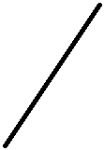

|  |  |  |  |
| --- | --- | --- | --- |
| double v[5]; | v[0] | 3 |  |
|  |  |  |
| v[0]=3; | v[1] |  |  |
| 2.7 |  |
| v[1]=2.7; |  |
| v[2] |  |  |
| v[2]=-0.45; | -0.45 |  |
|  |  |  |
| v[3]=3.7; | v[3] |  |  |
| 3.7 |  |
| v[4]=-0.5; |  |  |
| v[4] | -0.5 |  |
|  |  |
| **Figure 4.2.** One-dimensional array. | |  |  |



**Code4A.cpp: Sum and dot-product of vectors.**

#include <iostream>

#define N 3

using namespace std;

void main()

{

int i;

double z=0,u[N+1],v[N+1],w[N+1]; u[1]=2; u[2]=‐1; u[3]=5;

v[1]=3; v[2]=4; v[3]=‐1;

cout << "u\t" << "v\t" << "w" << endl; for (i=1; i<=N; i++)

{

w[i]=u[i]+v[i];

cout << u[i] << "\t" << v[i] << "\t" << w[i] << endl; z += u[i]*v[i];

}

cout << "the dot product is " << z << endl; cin.get();

}

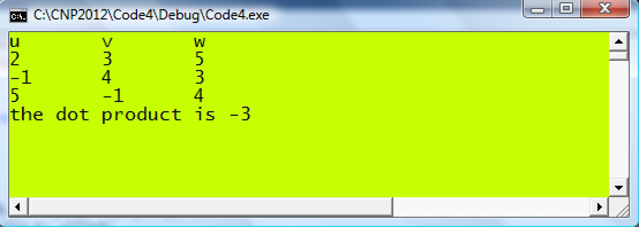

Sum of numbers



The sum is evaluated easily using the for loop, given by

|  |  |  |  |  |
| --- | --- | --- | --- | --- |
| int | z=0; |  |  |  |
| for (int i=1;i<=8;i++) | | |  |  |
|  | z += x[i]; |  |  |  |
| Note that an initial value of z=0 is required in the loop.  Product of numbers  Similarly, the product is evaluated by assigning w=1 as its initial value, as follows: | | | |  |
|  |  |  |  |  |

Summation of product numbers



has its solution written as

double s=0;

for (int i=1;i<=8;i++)

s+= pow(x[i],2)*sin(y[i]);



Let 

This simplifies the above expression into 

**Code4B.cpp: Summation using loop.**

#include <iostream>

using namespace std;

void main()

{

int i;

double x[6],y[6],p=0,q=0,r=1,z;

x[1]=3; x[2]=7; x[3]=‐1; x[4]=2; x[5]=9;

y[1]=‐5; y[2]=2; y[3]=8; y[4]=‐4; y[5]=1;

cout << "x\t" << "y\t" << endl;

for (i=1; i<=5; i++)

{

cout << x[i] << "\t" << y[i] << endl;

p += x[i]*cos(y[i]);

}

for (i=1;i<=3;i++)

q += pow(x[i],2);

for (i=1;i<=4;i++)

r *= y[i]*sin(x[i]);

z=(1+3*p)/sqrt(7*q‐5*r);

cout << "p=" << p << endl;

cout << "q=" << q << endl;

cout << "r=" << r << endl;

cout << "z=" << z << endl;

cin.get();

}

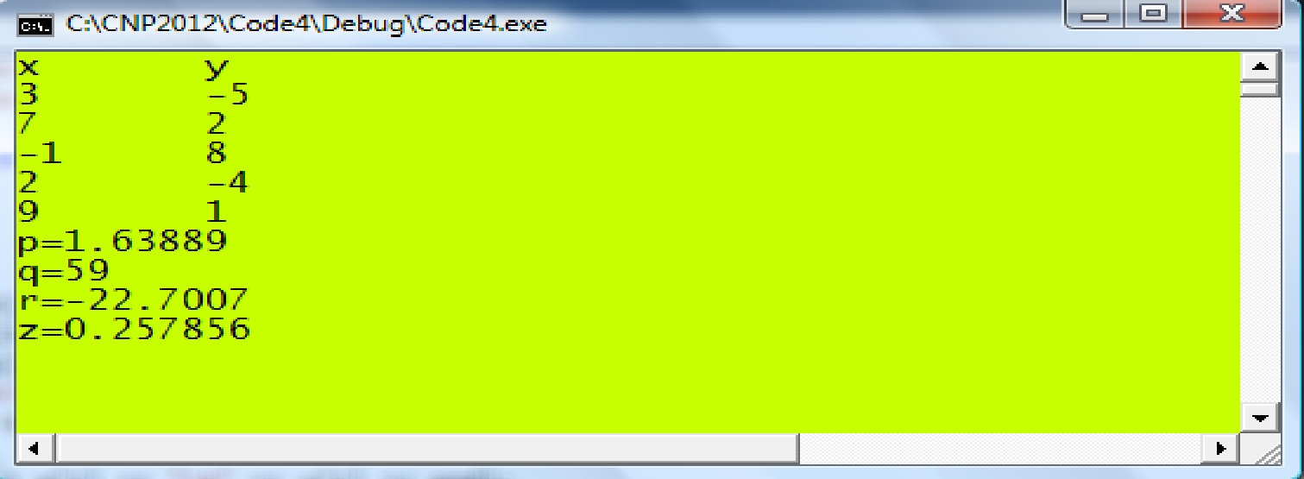

Random Number Generation

|  |  |  |  |  |  |  |  |  |
| --- | --- | --- | --- | --- | --- | --- | --- | --- |
|  | | **time()** | Initializes the clock. | | | |  |  |
|  | |  | |  | |  |  |
|  | |  |  | |  | |  |  |
|  | | return type | void | |  | |  |  |
|  | | arguments | void | |  | |  |  |
|  | | prototype | time.h | |  | |  |  |
|  | |  |  | | | |  |  |
|  | |  |  | | | |  |  |
|  | | **srand()** | Provides a seed value for the start. | | | |  |  |
|  | |  | |  | |  |  |
|  | |  |  | | | |  |  |
|  | | return type | TRUE or FALSE. | | | |  |  |
|  | | arguments | (int) | |  | |  |  |
|  | |  | |  | |  |  |
|  | | example | srand(3154) sets the initial seed to 3154. | | | |  |  |
|  | | prototype | iostream.h | | | |  |  |
|  | |  |  | | | |  |  |
|  | |  |  | | | |  |  |
|  | | **rand()** | Generates random number. | | | |  |  |
|  | |  | |  | |  |  |
|  | |  |  | |  | |  |  |
|  | | return type | int | |  | |  |  |
|  | | arguments | void | |  | |  |  |
|  | | prototype | iostream.h | | | |  |  |
|  | |  |  | |  | |  |  |
|  |  | |  | |  |  | |  |
|  | expression | |  |  | numbers generated |  | |  |
|  |  | |  |  |  |  |  |  |
|  | rand()%10 | |  |  | 0, 1, ..., 9 |  |  |  |
|  | rand()%100 | |  |  | 0, 1, ..., 99 |  |  |  |
|  | 1+rand()%10 | |  |  | 1, 2, ..., 10 |  |  |  |
|  | 1/(1+rand()%10) | | |  | 0.01, 0.02, ..., 1.0 |  |  |  |
|  |  | |  |  |  |  | |  |
|  | | |  | |  | | |  |

We illustrate the above concept through an example on finding the maximum and minimum of a set of numbers. Suppose there are six numbers, as follows:

49 64 95 83 27

First, assign an array to hold these values:

a[1]=49 a[2]=64 a[3]=95 a[4]=83 a[5]=27

Next, assign the first value into a variable, call it max:

max=a[1]

Run a loop with five repeats, and at each time compare the values to get the following results:

|  |  |  |  |  |  |  |  |  |  |  |  |  |  |  |  |
| --- | --- | --- | --- | --- | --- | --- | --- | --- | --- | --- | --- | --- | --- | --- | --- |
|  | Initial | *i* |  | 1 | *i* |  | 2 | *i* |  | 3 | *i* |  | 4 | *i* 5 |  |
|  |  |  |  |  |  |  |
| Comparison | a[i] | max | | | max | | | Max | | | max | | | max |  |
| max<a[1]? | 49 |  | 49 | |  |  |  |  |  |  |  |  |  |  |  |
| max<a[2]? | 64 |  |  |  |  | 64 | |  |  |  |  |  |  |  |  |
| max<a[3]? | 95 |  |  |  |  |  |  |  | 95 | |  |  |  |  |  |
| max<a[4]? | 83 |  |  |  |  |  |  |  |  |  |  | 95 | |  |  |
| max<a[5]? | 27 |  |  |  |  |  |  |  |  |  |  |  |  | 95 |  |

**Code4C.cpp: Computing the maximum of numbers.**

#include <iostream>

#include <time.h>

using namespace std;

void main()

{

int a[10], max, i; srand(time(0));

cout << "The random numbers are:" << endl << endl;

for (i=1;i<=5;i++)

a[i]=rand()%100; max=a[1];

cout << "i\t" << "a[i]\t" << "max" << endl; for (i=1;i<=5;i++)

{

if (a[i]>max) max=a[i];

cout << i << "\t" << a[i] <<"\t"<<max<<endl;

}

cin.get();

}

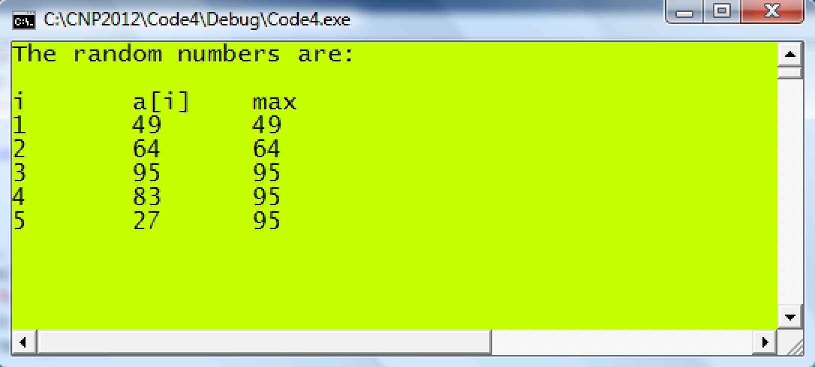

**Code4D.cpp: Statistical analysis of numbers.**

#include <iostream> #define N 8

using namespace std;

void main()

{

int i;

double a[N+1], Sum=0, Max, Min, Mean;

srand(time(0));

for (i=1;i<=N;i++)

a[i]=1/((double)1+rand()%10); // random numbers from 0.1 to 1.00 Max=a[1];

Min=a[1];

for (i=1;i<=N;i++)

{

cout << i << "\t" << a[i] << endl; if (Max<=a[i])

Max=a[i]; if (Min>=a[i])

Min=a[i]; Sum += a[i];

}

Mean=Sum/N;

cout << "The maximum number is " << Max << endl; cout << "The minimum number is " << Min << endl;

cout << "The sum of all the numbers is " << Sum << endl; cout << "The mean is " << Mean << endl;

double SumSquare=0,Variance,StdDev; SumSquare=0;

for (i=1;i<=N;i++) SumSquare+=pow(a[i]‐Mean,2);

Variance=SumSquare/(N‐1); StdDev=sqrt(Variance);

cout << "The variance is " << Variance << endl;

cout << "The standard deviation is " << StdDev << endl;

cin.get();

}

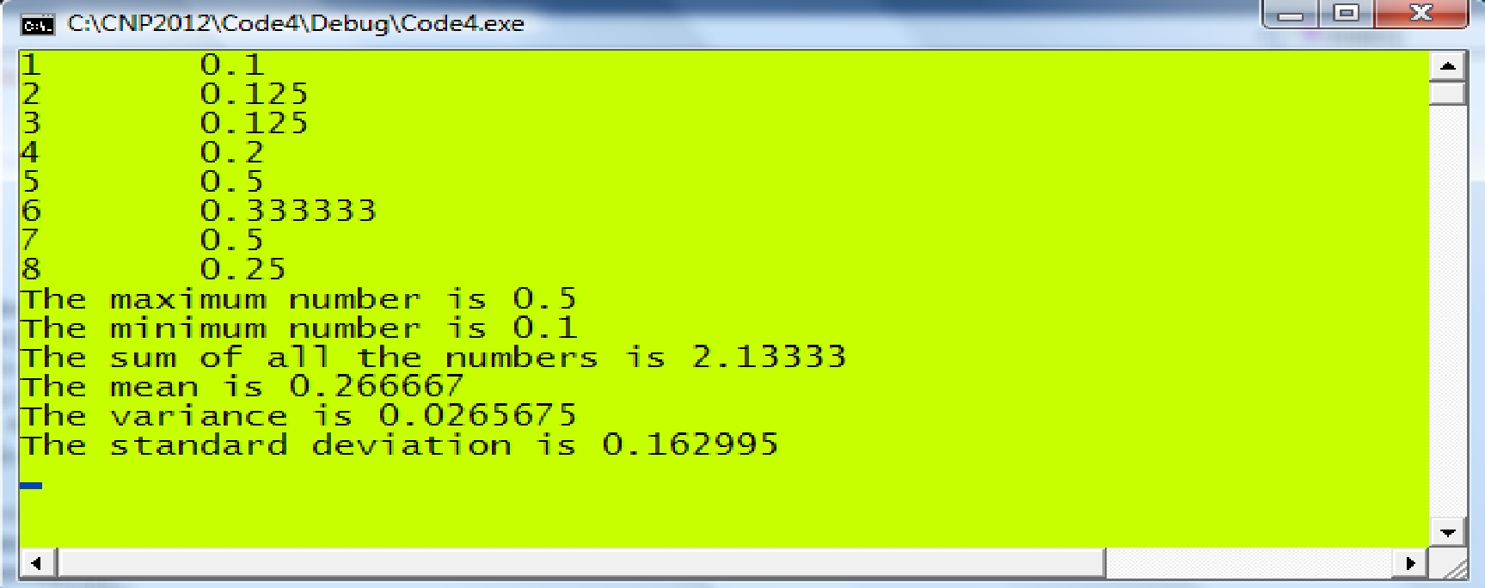

Two-dimensional Array

int q[3][4]={5,‐2,0,7,8,1,‐1,4,‐7,3,2,5};

q[0][0]



q[0][1]



q[0][2] q[2][3]



q[0][3]



int q[3][4]={5,-2,0,7,8,1,-1,4,-7,3,2,5};

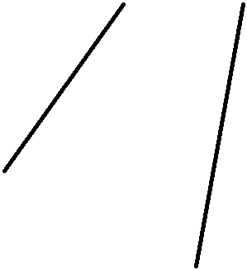

row 0 row 1 row 2

*number of rows*

*number of columns*

|  |  |  |  |  |  |
| --- | --- | --- | --- | --- | --- |
|  | *column* 0 | *column* 1 | *column* 2 | *column* 3 |  |
|  |  |  |  |  |  |
| *row* 0 | 5 | -2 | 0 | 7 |  |
|  |  |
|  |  |  |  |  |  |
| *row* 1 | 8 | 1 | -1 | 4 |  |
|  |  |
|  |  |  |  |  |  |
| *row* 2 | -7 | 3 | 2 | 5 |  |
|  |  |
|  |  |  |  |  |  |

**Matrix Multiplication.**



For example,  and  for  are multiplied to produce  according to:



**Simplifies as:**



for *i=1,2, … , m* and *j=1,2,…, n,*  where *m=3, n=2*  and *p=4.*

int m=3, n=2, p=4;

for (int i=1; i<=m; i++)

for(int j=1; j<=n; j++)

for(int k=1; k<=p; k++)

c[i][j]+=a[i][k]*b[k][j];

**Code4E.cpp: Matrix Multiplication.**

#include <iostream>

#define m 3

#define n 2

#define p 4

using namespace std;

void main()

{

int i,j,k;

int a[m+1][p+1], b[p+1][n+1], c[m+1][n+1];

a[1][1]=2; a[1][2]=-3; a[1][3]=1; a[1][4]=5;

a[2][1]=-1; a[2][2]=4; a[2][3]=-4; a[2][4]=-2;

a[3][1]=0; a[3][2]=-3; a[3][3]=4; a[3][4]=2;

b[1][1]=4; b[1][2]=-1;

b[2][1]=3; b[2][2]=2;

b[3][1]=1; b[3][2]=-1;

b[4][1]=-2; b[4][2]=4;

cout << "Matrix A:" << endl;

for (i=1; i<=m; i++)

{

for (j=1;j<=n;j++)

cout << a[i][j] << "\t";

cout << endl;

}

cout << endl << "Matrix B:" << endl;

for (i=1; i<=p; i++)

{

for (j=1; j<=n; j++)

cout << b[i][j] << "\t";

cout << endl;

}

cout << endl << "Matrix C (A multiplied by B):" << endl;

for (i=1; i<=m; i++)

{

for (j=1;j<=n;j++)

{

c[i][j]=0;

for (k=1;k<=p;k++)

c[i][j] += a[i][k]*b[k][j];

cout << c[i][j] << "\t";

}

cout << endl;

}

cin.get ();

}

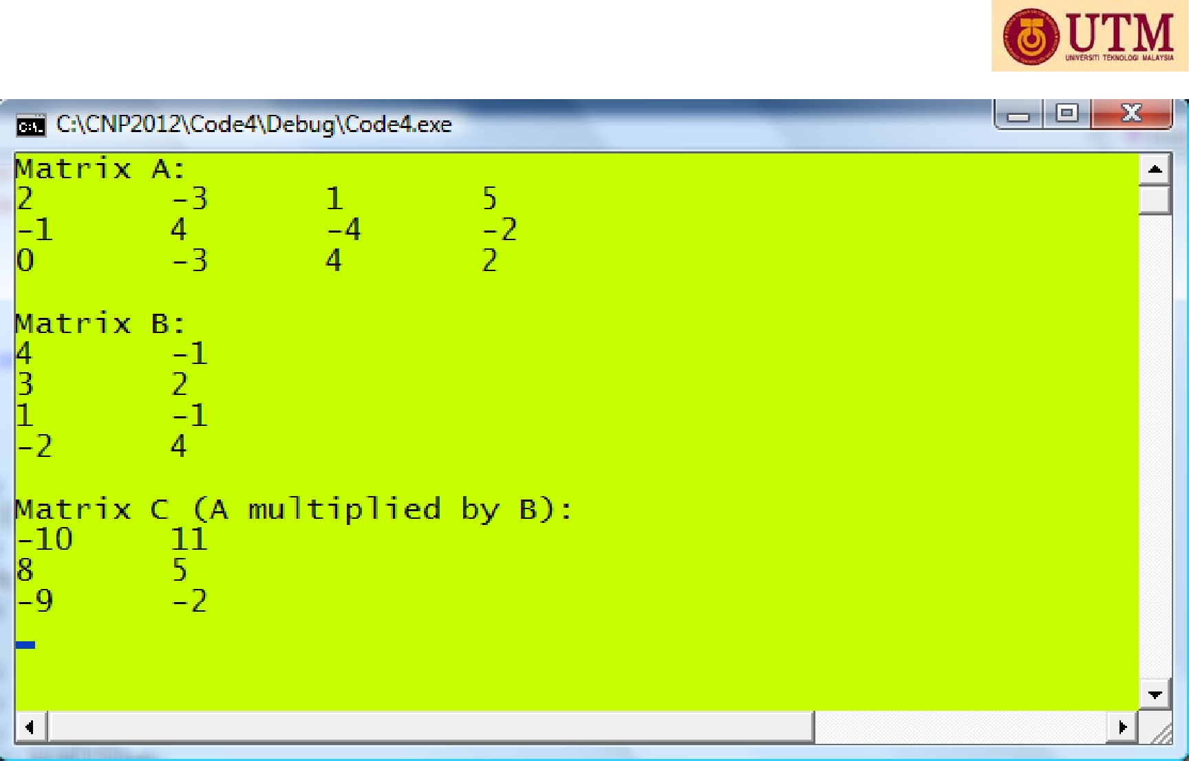

String

- an array of characters

char str[20]; strcpy(str,”Kedah”);

OR

char str[20]=”Kedah”;

OR

char str[]=”Kedah”;

OR

char *str=”Kedah”;

*name of string*

|  |  |
| --- | --- |
| *type of array* | *size of string* |
|  |  |

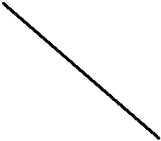

char str[30];

str[0]='K'; str[1]='e'; str[2]='d'; str[3]='a'; str[4]='h'; str[5]='\0';

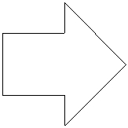

|  |  |  |
| --- | --- | --- |
| str[0] | 'K' |  |
|  |  |
|  |  |  |
| str[1] | 'e' |  |
|  |  |
|  |  |  |
| str[2] | 'd' |  |
|  |  |
|  |  |  |
| str[3] | 'a' |  |
|  |  |
|  |  |  |
| str[4] | 'h' |  |
|  |  |
|  |  |  |
| str[5] | '\0' |  |
|  |  |
|  |  |  |

|  |  |  |  |
| --- | --- | --- | --- |
| Array of strings |  |  |  |
| maximum number of strings |  |  |  |
| maximum size of each string |  |  |  |
| char str[5][15]; | str[0] |  |  |
| "Tokyo" |  |
|  |  |
| strcpy(str[0],"Tokyo"); | str[1] | "Istanbul" |  |
| strcpy(str[1],"Istanbul"); |  |
| str[2] | "Sydney" |  |
| strcpy(str[2],"Sydney"); |  |
| strcpy(str[3],"Auckland"); | str[3] | "Auckland" |  |
| strcpy(str[4],"Washington"); | str[4] |  |  |
| "Washington" |  |
|  |  |

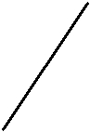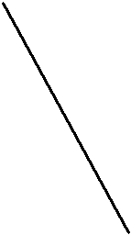

|  |  |  |  |  |
| --- | --- | --- | --- | --- |
| VC2010 |  | **Code4F.cpp:** String manipulation. | |  |
|  |  |  |
| #include <iostream> | | |  |  |
| using namespace std; | | |  |  |
| void main() | | |  |  |
| { |  |  |  |  |
|  | int i; | |  |  |
|  | char str1[10], str2[10], str3[20]; | | |  |
|  | cout << "Enter a string: "; | |  |  |
|  | cin >> str1; | |  |  |
|  | cout << str1 << endl; | | // display the whole string in str1 |  |
|  | for (i=0; i<=strlen(str1)‐1; i++) | | |  |
|  |  | cout << str1[i]; | // display str1 character by character |  |
|  | cout << endl; | |  |  |
|  | cout << "Your str1 input is " << str1 << endl; | | |  |
|  | cout << "Enter another string: "; | | |  |
|  | cin >> str2; | |  |  |
|  | cout << "Your str2 input is " << str2 << endl; | | |  |
|  | strcpy(str3,str1); | | // copy and overwrite str1 into str3 |  |
|  | strcat(str3," "); | | // add " " into str3 |  |
|  | strcat(str3,str2); | | // add str2 into str3 |  |
|  | cout << "The whole string is " << str3 << endl; | | |  |
|  | cout << "Length of string " << str1 << " is " << strlen(str1) << endl; | | |  |
|  | cout << "Length of string " << str2 << " is " << strlen(str2) << endl; | | |  |
|  | cout << "Length of string " << str3 << " is " << strlen(str3) << endl; | | |  |
|  | cin.get(); | |  |  |
| } |  |  |  |  |

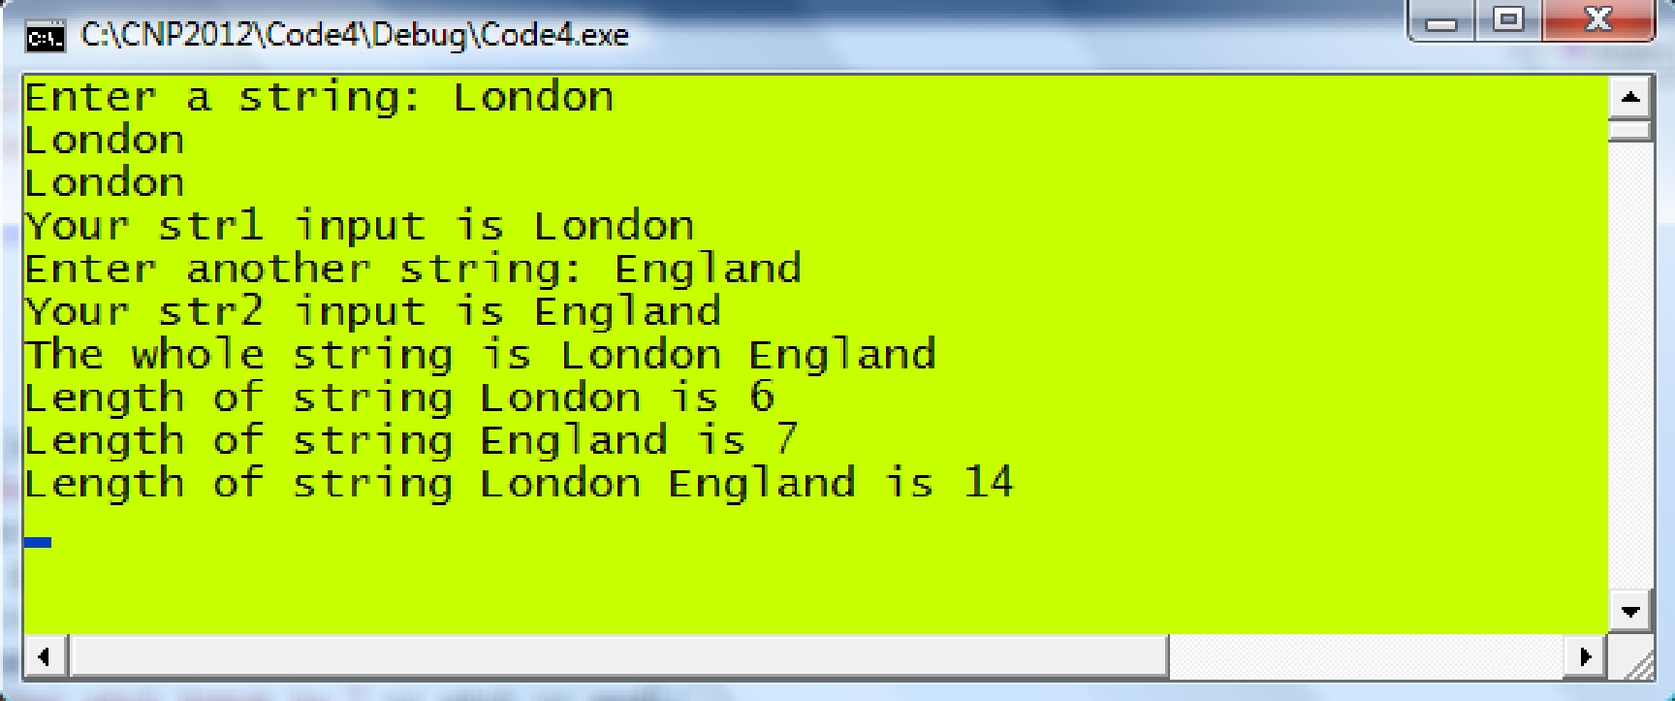

File Input/Output (I/O)

To read data from a text file:

|  |  |  |
| --- | --- | --- |
|  | ***Step*** | ***How to do it?*** |
|  |  |  |
|  | *Declare an input pointer* | ifstream *ifp* |
|  | *Open the file by referring it as the input pointer* | *ifp.*open() |
|  | *Read the data through the right indirection operator (>>)* | *ifp* >> *array* |
|  | *Close the file* | *ifp*.close() |
|  | To save data into a text file: |  |
|  |  |  |
|  | ***Step*** | ***How to do it?*** |
|  |  |  |
|  | *Declare an output pointer* | ofstream *ofp* |
|  | *Open the file by referring it as the output pointer* | *ofp.*open() |
|  | *Store the data through the left indirection operator (<<)* | *ofp* << *array* |
|  | *Close the file* | *ofp*.close() |

**Code4G.cpp: File saving and reading.**

#include <iostream>

#include <fstream>

using namespace std;

void main()

{

char name[10][15]; int i,age[10];

// write the array data into a file ofstream ofp; ofp.open("code4G.out",ios::out); strcpy(name[1],"Ahmad"); age[1]=25; strcpy(name[2],"Joseph"); age[2]=32; strcpy(name[3],"Azhar"); age[3]=27; strcpy(name[4],"Shazli"); age[4]=30; for (i=1;i<=4;i++)

ofp << name[i] << "\t" << age[i] << endl; ofp.close();

// read the saved data to verify char Name[10][15];

int Age[10]; ifstream ifp;

ifp.open("code4G.out",ios::in); for (i=1;i<=4;i++)

{

ifp >> Name[i] >> Age[i];

cout << Name[i] << "\t" << Age[i] << endl;

}

ifp.close(); cin.get();

}

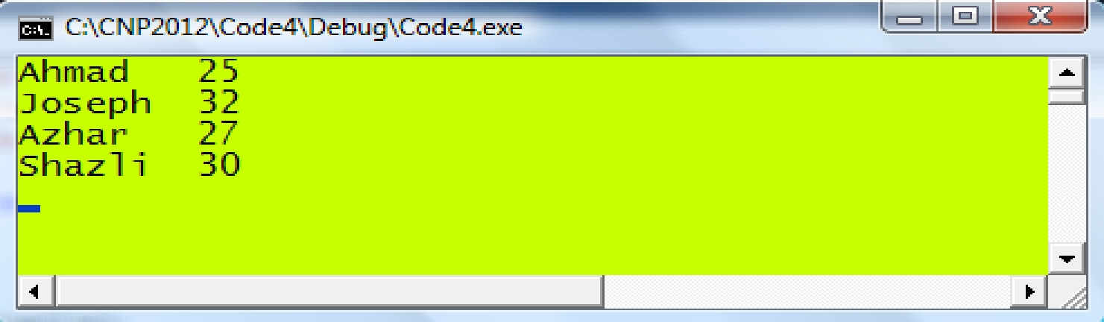

**Reading/Writing a Table of Data**

|  |  |  |  |  |
| --- | --- | --- | --- | --- |
| 3 | -2 | 4 | 7 | *i*=1 |
| 4 | 2 | 7 | -1 | *i*=2 |
| -2 | 5 | 1 | 3 | *i*=3 |

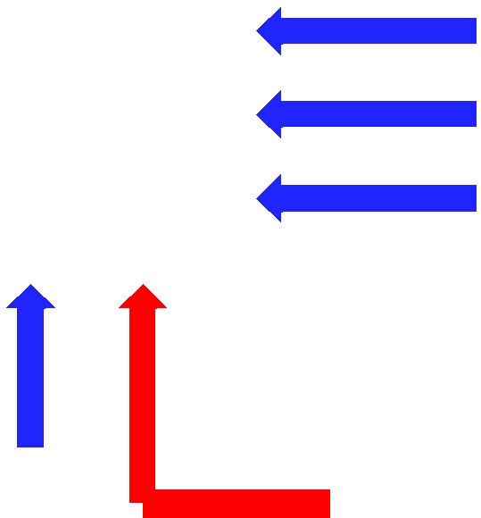

|  |  |  |  |  |  |
| --- | --- | --- | --- | --- | --- |
| *j*=1 | *j*=2 | *j*=3 |  | *b*[i] updated |  |
|  |  |
|  |  |

*a*[i] updated

|  |  |  |  |  |
| --- | --- | --- | --- | --- |
| int i,j; | |  |  |  |
| for (int i=1;i<=n;i++) | | *// the rows* |  |  |
| { | for (int j=1;j<=n;j++) | *// the columns* |  |  |
|  |  |  |
|  | ifp >> a[i][j]; | *// read columns 1-3, assign to* | *A* |  |
|  | ifp >> b[i]; | *// read column 4, assign to* ***b*** |  |  |
| } |  |  |  |  |
|  |  |  | |  |

**Code4H.cpp: Reading a table of data.**

#include <iostream>

#include <fstream>

#define n 3

using namespace std;

void main()

{

double a[n+1][n+1],b[n+1]; ifstream ifp; ifp.open("Code4H.in",ios::in);

cout << "Data read from Code4H.in" << endl; for (int i=1;i<=n;i++)

{

for (int j=1;j<=n;j++)

{

ifp >> a[i][j];

cout << a[i][j] << " ";

}

ifp >> b[i];

cout << b[i] << endl;

}

ifp.close(); cin.get();

}

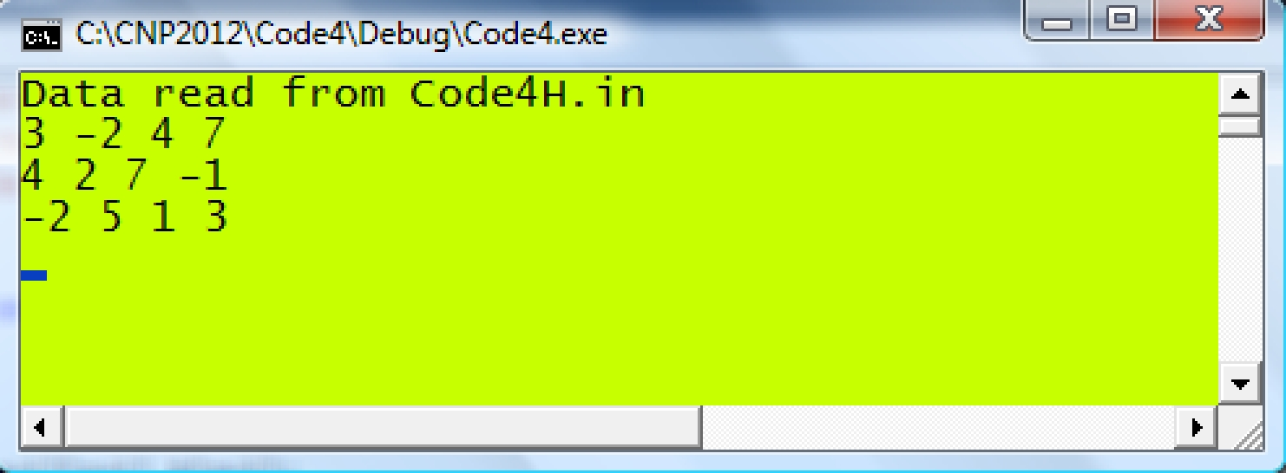

**Dynamic Memory Allocation**

*Static memory allocation* refers to a fixed allocation of memory chunks to arraysno matter the memories are actively used or not.

*Dynamic memory allocation* is a dynamic way of allocating memory to arrayswhere only active arrays are allocated.

1D-Array

*Static Memory Allocation*

int v[N+1];

*// place more codes here*



*Dynamic Memory Allocation*

int *v; *// declares a pointer to the array*

v=new int [N+1]; *// allocates memory of size N+1*

*// place more codes here*

delete v; *// destroys the array and return the memory*

**Code4I.cpp: Sum and dot product problem revisited.**

#include <iostream>

#define N 3

using namespace std;

void main()

{

int i;

double z=0, *u, *v, *w; u=new double [N+1]; v=new double [N+1]; w=new double [N+1]; u[1]=2; u[2]=‐1; u[3]=5; v[1]=3; v[2]=4; v[3]=‐1;

cout << "u\t" << "v\t" << "w" << endl; for (i=1; i<=N; i++)

{

w[i]=u[i]+v[i];

cout << u[i] << "\t" << v[i] << "\t" << w[i] << endl; z += u[i]*v[i];

}

cout << "the dot product is " << z << endl; delete u,v,w;

cin.get();

}

2D-Array

*Static Memory Allocation*

int q[M+1][N+1];

*// place more codes here*



|  |  |  |
| --- | --- | --- |
| *Dynamic Memory Allocation* |  |  |
| int **q; |  | *// declares a pointer to the array* |
| v=new int *[M+1]; |  | *// allocates memory to M+1 rows* |
| for (int i=0;i<=M;i++) | |  |
| q[i]=new int [N+1]; | | *// allocates N+1 columns* |
| *// place more codes here* |  |  |
| delete q; | *// destroys the array and return the memory* | |

**Code 4J.cpp:Matrix multiplication problem revisisted**

|  |  |  |  |  |  |  |  |  |  |
| --- | --- | --- | --- | --- | --- | --- | --- | --- | --- |
|  |  |  | | | | |  |  |  |
| #include <iostream> | | | |  |  |  |  |  |  |
| #include <fstream> | | | |  |  | Code4J.in | |  |  |
| #define m 3 | | |  |  | 2 | ‐3 | 1 | 5 |  |
| #define n 2 | | |  |  | ‐1 | 4 | ‐4 | ‐2 |  |
| #define p 4 | | |  |  |  |
|  |  | 0 | ‐3 | 4 | 2 |  |
| using namespace std; | | | |  |  |
|  | 4 | ‐1 |  |  |  |
|  |  |  |  |  |  |  |  |
| void main() | | |  |  | 3 | 2 |  |  |  |
|  |  | 1 | ‐1 |  |  |  |
| { |  |  |  |  |  |  |  |
|  |  |  |  | ‐2 | 4 |  |  |  |
|  | int i,j,k; | | |  |  |  |  |
|  |  |  |  |  |  |  |
|  |  |  | |  |  |  |  |  |  |
|  | int **a,**b,**c; | | | a=new int *[p+1]; | |  |  |  |  |
|  | b=new int *[p+1]; | | |  |  |  |  |  |  |
|  | c=new int *[p+1]; | | |  |  |  |  |  |  |
|  | for (i=0;i<=p;i++) | | |  |  |  |  |  |  |
|  | { | |  |  |  |  |  |  |  |
|  |  |  | a[i]=new int [p+1]; | | |  |  |  |  |
|  |  |  | b[i]=new int [p+1]; | | |  |  |  |  |
|  |  |  | c[i]=new int [p+1]; | | |  |  |  |  |
|  | } | | ifstream ifp("Code4J.in"); | | |  |  |  |  |

cout << "Matrix A" << endl; for (i=1;i<=m;i++)

{

for (j=1;j<=p;j++)

{

ifp >> a[i][j];

cout << a[i][j] << " ";

}

cout << endl;

}

cout << endl << "Matrix B" << endl; for (i=1;i<=p;i++)

{

for (j=1;j<=n;j++)

{

ifp >> b[i][j];

cout << b[i][j] << " ";

}

cout << endl;

}

ifp.close();

cout << endl << "Matrix C (A multiplied by B):" << endl;

for (i=1; i<=m; i++)

{

for (j=1;j<=n;j++)

{

c[i][j]=0;

for (k=1;k<=p;k++)

c[i][j] += a[i][k]*b[k][j]; cout << c[i][j] << " ";

}

cout << endl;

}

delete a,b,c; cin.get();

}

MAIN REFERENCE:

Shaharuddin Salleh (2012), C++ Numerical Programming.