http://www.skagitwatershed.org/~donclark/history_isd/isdhistory.html

A Brief History of Instructional System Design

http://www.skagitwatershed.org/~donclark/history_isd/acronym.html

ADDIE the Acronym - 1995
While the ADDIE model has been around since at least 1975, it was generally known as SAT (System Approach to Training) and later, ISD (Instructional System Development). The use of the ADDIE acronym did not come about until much later. Now there are probably earlier uses, but these are the earliest references that I have been able to locate that actually use the acronym of "ADDIE."

1. Schlegel, M. J. (1995) A Handbook of Instructional and Training Program Design. ERIC Document Reproduction Service ED383281
I have not actually read the handbook, but an abstract that I found in my library's database (Sno-Isle Libraries), in part, reads as: "The generic Design Model of Analyze, Design, Development, Implementation, and Evaluation (ADDIE) is utilized, and detailed job aids are provided in the form of rating sheets and checklists."

2. Molenda, M., Pershing, J. A., and Reigeluth, C.. M. (1996). Designing Instructional Systems. In Robert L. Craig (Ed.), The ASTD Training and Development Handbook 4th ed. (pp. 266-293). New York: McGraw-Hill.
On page 272, there is a chart showing the five phases of ISD. The caption reads: Figure13-2. Breakdown of phases and steps in the "ADDIE" ISD Model.

3. Gayeski, D. M. (1998). OUT-OF-THE-BOX INSTRUCTIONAL DESIGN. Training & Development, Apr 98, Vol. 52, Issue 4
The article refers to Rossett's (1987) writings on Analysis, Design, Development, Implementation, and Evaluation model, or ADDIE. However, Michael Molenda writes in The ADDIE Model (submitted to Encyclopedia of Educational Technology, 2/5/03, to be published by ABC-CLIO) that Rossett's book does not contain the acronym "ADDIE."
Rossett, (1987). Training Needs Assessment. Englewood Cliffs, NJ: Educational Technology Publications, Inc.

1995, 1996, 1998

Thus, it seems as if the acronym "ADDIE" did not make its way into the popular literature until the mid 1990s, while the ISD model itself has been in use since 1975.
http://www.skagitwatershed.org/~donclark/history_isd/addie.html

ADDIE - 1975
In 1975, Florida State University developed the ADDIE model of Analysis, Design, Development, Implementation, and Evaluation, which was selected by the Armed Services as the primary means for developing training. At the time, the term "ADDIE" was not used, but rather "SAT" (Systems Approach to Training) or "ISD" (Instructional Systems Development). As a generally rule, the military used SAT, while their civilian counterparts used ISD. The "D" in "ISD" first stood for "Development," but now normally means "Design."
The ISD model at the time looked similar to this:
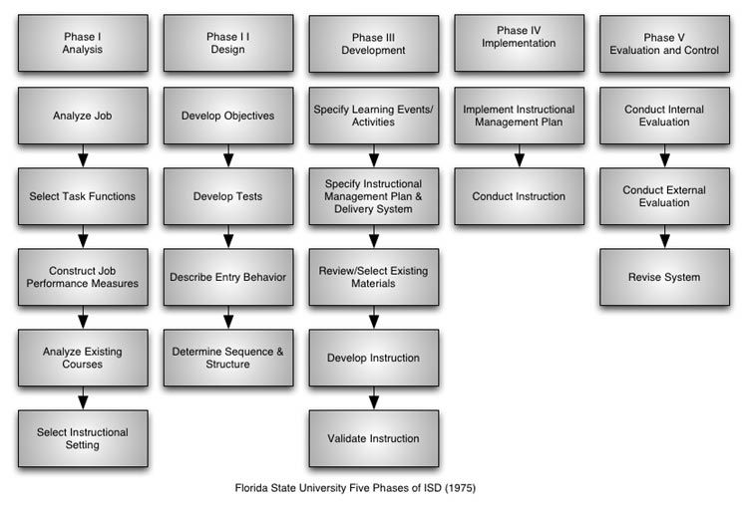
Six years later, Dr. Russell Watson, Chief, Staff and Faculty Training Division of the Fort Huachuca, Arizona, presented a paper to International Congress for Individualized Instruction. In it, he discusses the U.S. Army's SAT model as developed by Florida State University. However, he uses a slightly different model in which the five basic phases are still the same, but the steps within each phase have been slightly modified:
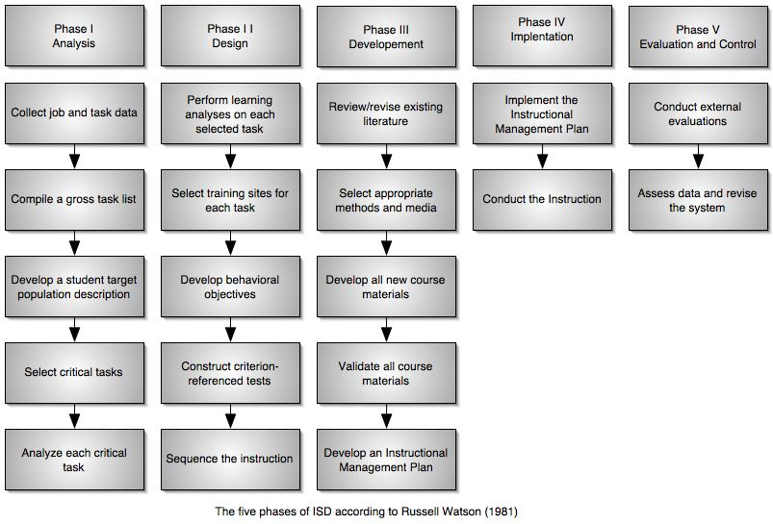

As defense machinery was becoming more and more sophisticated, the educational background of entry level soldiers was becoming lower and lower. The potential solution to this problem was in the form of a "systems approach" to training. The system selected for use by the Army was Instructional Systems Development (ISD), developed in 1975 by Florida State University. ISD is a comprehensive five phase process encompassing the entire training/educational environment. Although ISD is a systematic step-by-step approach, it has the flexibility to be used with both individualized and traditional instruction. It is however, specifically orientated towards the use of behavioral/performance objectives and criterion-referenced tests. -- Russell Watson (1981)

Reference
Watson, Russell (October 1981). Instructional System Development. In a paper presented to the International Congress for Individualized Instruction. EDRS publication ED 209 239. Branson, R. K. (principal investigator) (1975). Interservice procedures for instructional systems development: Executive summary and model. Tallahassee, FL: Center for Educational Technology, Florida State University. (National Technical Information Service, 5285 Port Royal Rd., Springfield, VA 22161. Document Nos. AD-A019 486 to AD-A019490)
Branson, R.K., Rayner, G.T., Cox, J.L., Furman, J.P., King, F.J., Hannum, W.H. Interservice procedures for instructional systems development. (5 vols.) (TRADOC Pam 350-30 NAVEDTRA 106A). Ft. Monroe, VA: U.S. Army Training and Doctrine Command, August 1975. (NTIS No. ADA 019 486 through ADA 019 490):
- Executive Summary and Model - ADA 019 486
- Phase I: Analyze - ADA 019 487
- Phase II: Design - ADA 019 488
- Phase III: Develop - ADA 019 489
- Phase IV & V: Implement and Control - ADA 019 490
http://www.skagitwatershed.org/~donclark/history_isd/roots.html

Roots and Connections of ISD - 1940s to 1960s
While Ludwig von Bertalanffy created the general systems theory in the 1940's, it took several others to create a set of general instructional/learning/training theories so that others could make the connection between systems and the learning/training process o create the ISD that we know of today.

B. F. Skinner - Behaviorism and Programmed Instruction - 1940s
Although John B. Watson founded behaviorism, B. F. Skinner refined and popularized it. His Walden Two (1948) showed how behaviorism's principles could be applied to society, later, Beyond Freedom and Dignity (1971), an analysis of culture, would become a best seller.
His main principle, operant conditioning differs from classical conditioning in that operant conditioning apples to voluntary behavior, while classical conditioning apples to reflexes. Its influence on ISD in that behavior, in this case learning, can be influenced by manipulating the environment. That is, put the right process in place (system) and you can provide an environment for learning.
Skinner's second contribution is programmed instruction that is characterized by clearly stated behavioral objectives, small frames of instruction, self-pacing, active learner response to inserted questions, and immediate feedback regarding the correctness of a response. Individualized instruction in essence replaces the teacher with systematic or programmed materials.

Benjamin Bloom - Taxonomy of Intellectual Behaviors - 1956
There is more than one type of learning. A committee of colleges, led by Benjamin Bloom, identified three domains of educational activities: cognitive, affective, and psychomotor. Since the work was produced by higher education, the words tend to be a little bigger than we are normally used to. Domains can be thought of as categories. Cognitive is for mental skills (Knowledge), affective is for growth in feelings or emotional areas (Attitude), while psychomotor is for manual or physical skills (Skills). Trainers often refer to these as KSA. This taxonomy of learning behaviors can be thought of as "the goals of the training process." That is, after the training session, the learner should have acquires these new skills, knowledge, or attitudes.
The committee then produced an elaborate compilation for the cognitive and affective domains, but none for the psychomotor domain. Their explanation for this oversight was that they have little experience in teaching manual skills within the college level (I guess they never thought to check with their sports or drama department).
This compilation divides the three domains into subdivisions, starting from the simplest behavior to the most complex. The divisions outlined are not absolutes and there are other systems or hierarchies that have been devised in the educational and training world. However, Bloom's taxonomy is easily understood and is probably the most widely applied one in use today

Robert Mager - Learning Objectives - 1962
Robert Mager's learning objectives is perhaps the key cornerstone of ISD as it gives the system a purpose:
- Observable Action (task) - This describes the observable performance or behavior. An action means a verb must be in the statement, for example "type a letter" or "lift a load." Each objective covers one behavior, hence, only one verb should be present. If the are many behaviors or the behaviors are complicated, then the objective should be broken down into one or more enabling learning objectives that supports the main terminal learning objective.
- At Least One Measurable Criterion (standard) - This states the level of acceptable performance of the task in terms of quantity, quality, time limitations, etc. This will answer any question such as "How many?" "How fast?" or "How well?". For example "At least 5 will be produced", "Within 10 minutes", "Without error". There can be more than one measurable criterion. Do not fall into the trap of putting in a time constraint because you think there should be a time limit or you cannot easily find another measurable criterion. Use a time limit only if required under the normal working standards.
- Conditions of performance (usually) (condition) - Describes the actual conditions under which the task will occur or be observed. Also, it identifies the tools, procedures, materials, aids, or facilities to be used in performing the task. This is best expressed with a prepositional phase such as "without reference to a manual" or "by checking a chart".

Robert Glaser - Testing - 1962
Robert Glaser was the first to use the term criterion-referenced measure. Glaser indicated that such instruments could be used to assess student entry-level behavior and thus, determine the extent to which students had acquired the needed behaviors or objectives. Such measurements not only allowed one to test the learners, but also test the system.

Robert Gagne - Instruction - 1965
Robert Gagne's Nine Steps of Instruction's gives the system a process:
- Gain attention: Present a problem or a new situation.
- Inform learner of Objective - Allows the learners to organize their thoughts and around what they are about to see, hear, and/or do.
- Stimulate recall of prior knowledge. Allows the learners to build on their previous knowledge or skills.
- Present the material - Chunk the information to avoid memory overload and blend the information to aid in information recall.
- Provide guidance for learning - This is not the presentation of content, but rather the instructions on how to learn.
- Elicit performance - Practice by letting the learner do something with the newly acquired behavior, skills, or knowledge.
- Provide feedback - Show correctness of the learner's response, analyze learner's behavior.
- Assess performance - Test to determine if the lesson has been learned.
- Enhance retention and transfer - Inform the learner about similar problem situations, provide additional practice, put the learner in a transfer situation, review the lesson.

Reference
Bloom, B. S., Mesia, B. B., and Krathwohl D.R. (1964). Taxonomy of Educational Objectives (two vols: The Affective Domain & The Cognitive Domain). New York:
- Taxonomy of Educational Objectives: The Classification of Educational Goals by Benjamin S. Bloom
- Taxonomy of Educational Objectives, Handbook 1: Cognitive Domain
- by David Krathwohl (1956)
- Taxonomy of Educational Objectives Book 2/Affective Domain David Krathwohl (1999)
Gagne, R. M. (1965). The Conditions of Learning. New York: Holt, Rinehart & Winston.
Glaser, R., & Klaus, D.J. (1962). Proficiency measurement: Assessing human performance. In R.M. In R.M. Gagne's (Ed .), Psychological principles in system development. New York: Holt, Rinehart and Winston.
Mager, Robert F. (1962). Preparing Instructional Objectives. Palo Alto, Calif.: Fearon Publishers.
Saettler, Paul (1990). The Evolution of American Educational Technology. Englewood, Colorado: Libraries Unlimited, Inc., p. 350.
http://www.skagitwatershed.org/~donclark/history_isd/gagne.html

Psychological Principles in System Development - 1962
Robert M. Gagne edited the ground breaking Psychological Principles in System Development (1962). New York: Holt, Rinehart and Winston, Inc. This is a presentation on an integrated psychotechnology of system development
Gagne discusses the Air Force's formalization of the systems concept in the post WWII 1950's and its influence on air traffic control. The main theme of system design was to integrate people and machines into an operational system. While engineers generally concentrated on machines, this collection of works focuses on man and his interaction with machines, devices, and technology (political correctness was not in vogue at the time).

Planning for Human Components in System Development
System design begins with a state of purpose. The chart below shows Gagne's procedures used in system development.
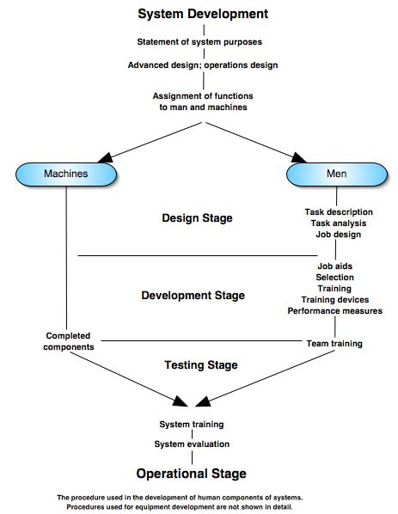

SHOCKACTION
One of the interesting system development projects discussed in the book is building a revised course of instruction for armor crewman training at Fort Knox, Kentucky. The project was code named SHOCKACTION and undertaken during the late 1950s. The course trained tank crewmen to act as a tank commander, driver, gunner, or loader of the Army's main battle tank. The course was considered important and worthy of considerable investment of research and development funds. It was noted by officers that the present course was not training armor crewmen to a level of proficiency.
The SHOCKACTION training revamp is discussed in two chapters (Concepts of Training by Meredith Crawford and The System Concept and Methodological Decision by John Finan) and is quite interesting as the newly developed course was not only superior to the old course, but also quite a bit shorter as the training was reduced from eight weeks to six weeks.
http://www.skagitwatershed.org/~donclark/history_isd/glaser.html

Robert Glaser - Instructional System - 1962
Robert Glasser first writes of an "instructional system" in 1962 (pp. 1-30). He describes it as being comprised of 1) Instructional Goals [system objectives], 2) Entering Behavior [system input], 3) Instructional Procedures [system operator], and 4) Performance Assessments [output monitor]. These in turn, tie into the "Research and Development Logistics." He gave a diagram similar to this one:
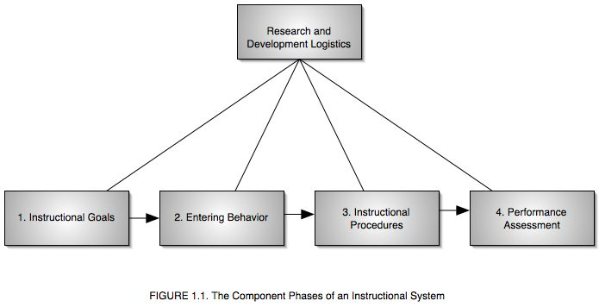
He writes (pp. 5-6):

The development of the system is initiated with the specification of the goals of instruction. These goals constitute the objective to be accomplished and the purpose for which the system is to be designed. The main input into the system, upon which it is designed to operate, consists of the entering behavior of the student. This consists of the initial repertoire, aptitudes, and prior educational background with which the instructional process begins. The next phase constitutes the actual instructional procedures and experiences which are employed to guide and modify behavior. The final phase in an instructional situation is some sort of "quality control," that is, assessment of the extent to which the end-of-course behavior has been achieved by he student in light of the kind of performance required by the specified instructional goals. These phases are the main flow of the instructional system, but it has many feedback loops and subsidiary inputs. The information obtained in each phase supplies data which are useful for monitoring and correcting the output of the preceding phase; for example, measurement of the kind of performance achieved can provide information for redesign of instructional procedures, and information on instructional procedures can interact with the characteristics of the entering behavior. Feeding in to all phases are the results of research and development. The implementation of these results and the fruitful interplay between research and development, on the one hand, and the operating aspects of the system, on the other, involve important logistical considerations.
The chapter then goes on for about 13 more pages covering the specifics of each phase.
In is interesting that although this book was published in 1962, the same year as Robert Mager published his "Preparing Instructional Objectives," he still speaks of obtaining "terminal behavior" which is defined as the performance that the learner should display at the end of a specific instructional situation (p.7).
Another interesting aspect is Glaser's distinction between learning and teaching, for he writes how the Zeitgeist of the times are bridging the "science of learning" and the "art of teaching" (p. 2). This is important, as while a "teaching system" can be quite linear, the very dynamics of learning demands that any instructional system that supports it must be quite flexible.
Glaser also discuses the difference between training and learning (pp. 4-5):
- Training: The end-products of learning can be specified in terms of particular instances of student performance (precision of behavioral end-products are specified. This implies a certain level of "uniformity."
- Education: The end-produce behaviors cannot be specified precisely because they are too complex. Maximize individual differences.
What is quite interesting about one of the first instructional systems is that it has a very dynamic, rather than linear look and feel to it. For rather than being a step-by-step model, it feeds and nourishes both forward and backwards. In addition, it loses it linear feature with the research and development activities being directed at each phase.

Reference
Glaser, R. (1962). Psychology and Instructional Technology. Training Research and Education. Edited by Glaser, R. Pittsburgh: University of Pittsburgh Press.

Notes
It is interesting to note that of the many references that Glaser cites, two of them are:
Bloom, B.S. (Ed.) (1956). Taxonomy of Educational Objectives. New York: Longmans, Green.
Skinner, B.F. (1959). Teaching Machines. In A.A. Lumsdine & R. Glaser (Ed.) Teaching Machines and Programmed Learning. Washington, D.C.: National Education Association. Pp. 137-158.
Not cited, but the second book of Taxonomy of Educational Objectives is:
David R. Krathwohl ,Benjamin S. Bloom ,Bertram B. Masia (1999). Taxonomy of Educational Objectives Book 2/Affective Domain. New York: Addison-Wesley.
http://www.skagitwatershed.org/~donclark/history_isd/airforce.html

The Air Force's Five Step Approach - 1965
According to Air Force Manual 36-2234, Instructional System Development (1 November 1993), the Air Force developed its first major instructional system in 1965. It describes the original Air Force ISD model as being a Five Step Approach, providing Feedback and Constraints, and being Flexible.

Five Step Approach
- Analyze System Requirements: This is done through occupational, job, and task analyses which result in statements of behavior, conditions, and standards for task performances.
- Define Education and Training Requirements: This step includes a needs analysis to determine if training is needed, assessment of target population characteristics, and selection of tasks for instruction through consideration of such factors as criticality, learning difficulty, and frequency of performance.
- Develop Objectives and Tests: The developer writes the three-part objectives that define what the students should be able to do after instruction, the conditions under which they may perform, and the acceptable standard of performance. The developer then writes test items to measure student performance on each objective.
- Plan, Develop, and Validate Instruction: In this step, the developer designs and produces course materials. The developer tries these materials out on students using the criterion test items to ensure that the students can achieve course objectives.
- Conduct and Evaluate Instruction: The course is fielded. Evaluation of instructional effectiveness continues for the life of the course and identifies needs that may develop for improving or updating the instruction.

Feedback and Constraints
This original model also shows 1) how the ISD process uses feedback and interaction among the functional blocks of activities to allow for continuous improvements to the products, and 2) how environmental constraints limit the designers' choices to what is possible.

Flexibility
The process allowed instructional developers to enter or reenter the steps of the ISD process as necessary to develop, update, or revise the instructional system. The Air Force model worked well and was considered adequate. It supported an instructional system that was focused primarily on classroom education and technical training delivered by an instructor using the lecture/demonstration method.

Note
The Air Force describes their updated ADDIE model (1993) as being a CYCLIC process (a circular or spiral arrangement) of ongoing continuous improvement. Where as their old 1965 model is linear.

http://www.skagitwatershed.org/~donclark/history_isd/saettler.html

Saettler's History of Instructional Technology - 1968

In the present book, we have been serving primarily as reporters, but also as interpreters (no human report can be absolutely objective) and critics. With the possible exception of programmed instruction, all of the historical instructional approaches presented so far in part 2 fall short of truly scientific technology of instruction. In contrast, the systems approach to instruction offers a conceptional framework which, hopefully, can provide a model for the achievement of this ideal. Since we are merely on the frontier of this development, much of this chapter will necessarily depart from the retrospective treatment of previous chapters and will focus instead on prospective developments. - Paul Saettler (1968).
Saettler broadly outlines instructional system development as having three components: design, development, and evaluation. The design phase is summarized as having "Where, when with what, and whom you must accomplish what, for whom, and where." Thus it begins with a specification of goals or purposes for the system. After the purpose has been stated, then the nature of the learners are described, requirements, etc. Thus, the design phase basically includes the analysis phase.
The development phase remains the same, but the evaluation phase includes operation and testing, with operation being the implementation of the program and of course testing being the evaluation. So in a nutshell, the five phases as we now know ISD has been compiled into three phases.

References
Saettler, Paul (1968). History of Instructional Technology. New York: McGraw-Hill.
Saettler, Paul (1990). The Evolution of American Educational Technology. Englewood, Colorado: Libraries Unlimited, Inc.
http://www.skagitwatershed.org/~donclark/history_isd/odiorne.html

George Odiorne - A System Approach to Training - 1968
George Odiorne's article, A Systems Approach to Training is published. Although still not the SAT or ISD that we now know, it lays some interesting background. He discusses the eight types of training systems that are often found in organizations:
- Static System of Training: This is a static structure best pictured as an organization chart. Objectives and definitions are the input, classes are the processes, and trained people are the output.
- The Clock Like System of Training: This is a structure based on time which is wound up at the beginning of a semester or season. Exact hours of training are laid out. The clock runs it course until the program is completed.
- The Cybernetic: This presumes that the needs will be identified, the training process will meet the needs, and evaluation will measure the effect. There is a plan for restoring organization performance to ideal levels by changing behaviors.
- The Cell System of Training: The training department is sustained on a self maintaining basis. It charges other departments for all cost of training, confident that it can sustain its own existence by providing training to line departments.
- The Plant System of Training: This is modeled after a central stem with branches and twigs. Branches such as sales training or leadership training can be snipped or grafted on.
- Training as a Organism: Analogous to an animal or a human. It has receptors, such as advisory groups and research which provide information to its brain. It often works at symbolic levels.
- Training Department as Social Organization: It is concerned with complex relations and numerous contact points.
- Training as a Social Movement: Closely associated with a social change movement, such as achieving an "industrial democracy."
Almost no real-life training and development operates wholly to anyone of the above training systems, but rather a combination or two or more. During this time frame (sixties and seventies), the training literature was becoming more and more inline with systems. And in particular, cybernetic systems. One of the major reason was the impact that Skinner and other behaviorists were having on the training industry.
Although cybernetic can mean a world of things depending on what perspective you are looking at it from, training professionals at this time looked upon it as a communication theory that treats organisms and organizations as being very much alike -- both display behavior. The term "cybernetic" [Greek kybernetes, pilot, steersman -- steering a ship on course to a desired destination] was coined by the mathematician Norbert Wiener in 1948 to describe the field of control and communication theory, whether it be by a human or in a machine. It treats not "things" but rather "ways of behaving."
Odiorne's Cybernetic model looks like this:
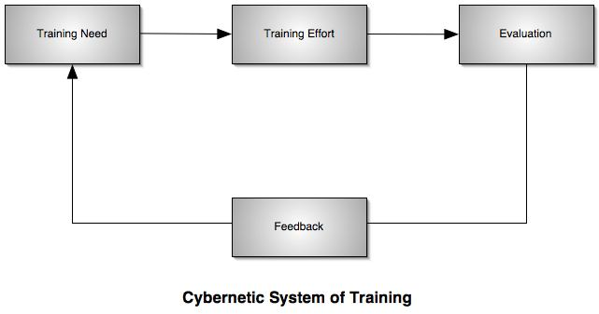

Reference
Odiorne, G. S. "A Systems Approach to Training." Training Director's Journal, 1965,19,10,11-19.

Notes

ASTD
The Training Director's Journal was the magazine of American Society of Training Directors, or ASTD, now called American Society of Training and Development.

Cybernetics
In 1993, physiologist Arturo Rosenblueth collaborated with MIT mathematician Norbert Wiener and engineer Julian Bielow to create an influential paper, "Behavior, Purpose, and Teleology" (1943), in which they establish a clear link between animate behavior and that of feedback-control systems. In addition, they maintained that purposeful behavior (either human or machine), did not require the teleological assumption of a future cause having a present effect. Rather purposeful behavior was a circular causation. Going one step more, Wiener published a ground breaking book, "Cybernetics" (1948), that continued the application of feedback to living organisms.

http://www.skagitwatershed.org/~donclark/history_isd/carey.html

The Dick and Carey Model - 1978
Although there are several versions ISD, with an almost unlimited number of flavors, the ADDIE model probably reigns supreme, with the Dick and Carey model following close behind it.
Dick and Carey's model details a comprehensive and detailed process, however, it has been criticized for at the same time being too rigid and cumbersome for the average design process.
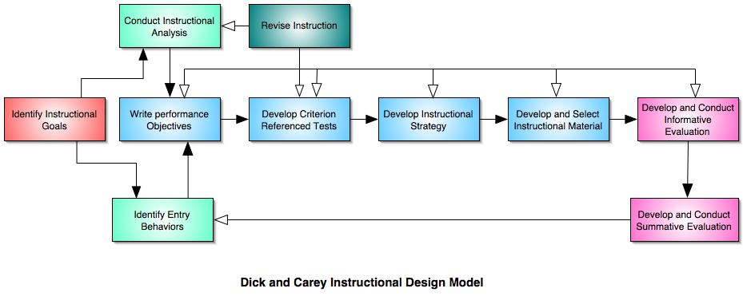

Reference
Dick, W., & Carey, L.(1978). The Systematic Design of Instruction. Glenview, IL.: Scott, Foresman.

http://www.skagitwatershed.org/~donclark/history_isd/abc.html

The ABCs of ISD - 1982
In the December 1982 edition of Training and Development Journal, Marc J. Rosenberg pens an article titled The ABCs of ISD in which he makes a couple of very interesting observations.

Front-End Analysis
There are often alternative methods to solving organization problems, such as organizational redesign, motivation strategies, and changes in reward structures, that may be more effective and cheaper than training. Thus, it is vital that a "front-end analysis" is performed in order to determine the best solution, rather than just selecting "training" because it was the first idea generated. While such analysis is not a part of ISD, the ISD model presupposes that a decision to develop training to solve a performance problem was selected because training was determined that to be the best solution.

Organization, Learner, and Job Needs
The ISD model requires that potential training problems be analyzed via a needs analysis to determine their exact nature. And while there may be a variety of factors to consider, the ISD model centers around three needs:
- Organizational needs are normally the most nebulous to assess because they are often quite vague or global in nature, such as "improve production" or "be a leader in our market." However, they can affect decisions about the trining, such as who gets trained and the resources allocated to training, thus they provide an important perspective for the rest of the ISD process.
- Learner needs are more specific, such as assessing previous experience and determining present performance deficiencies.
- Job needs are analyzed to determine the exact performance requirements (task analysis).

Prototypes
In the development phase, developmental testing or prototyping is used to test the instructional material to ensure they work as intended and to pinpoint if any process improvements can be made.

Relationship of Events
The ISD model is more than a sequence, rather it is a relationship of events.

It is this relationship which makes the model so effective in its application to training development. It ensures that a decision to develop training is based upon the realistic and identifiable needs of the organization, the learner, and the job. - Marc J. Rosenberg Training and Development Journal (December 1982).

