The Different Roles of Pedagogical Agents in the Open Source
Learning Management System

Hanafi Atan, Foo Kok Keong, +Baharudin Aris, *Wong Su Luan,
Omar Majid & Zuraidah Abd Rahman

School of Distance Education
Universiti Sains Malaysia
11800 Penang, Malaysia

*Faculty of Education
Universiti Putra Malaysia
Serdang, Selangor, Malaysia

+Department of Educational Multimedia
Universiti Teknologi Malaysia
81310, Skudai, Johor, Malaysia

ABSTRACT

The article reports on the development of instructional technology in the form of a pedagogical agent in the e-learning system utilising the latest virtual reality and artificial intelligence technology. The virtual reality technology allows the development of pedagogical agents with different personas and appearances assuming different roles in teaching or coaching the learners in their learning. Artificial intelligence is used to provide intelligent feedback in the form of computer generated voices and texts on the questions posed by the learners in accordance to their assigned instructional roles. The different instructional roles developed were the professor/lecturer, the tutor/facilitator and the peer/learning companion. These pedagogical agents were incorporated within the Moodle open source Learning Management System (LMS) used for the delivery of courses to Malaysian university students. The preliminary validation study on the instructional roles of these agents in terms of image and the scripts shows that learners’ perception on their instructional roles conformed to most of the intended roles indicated by the design of the images. In terms of the script validation study, the results revealed that the students’ perception towards the three versions of the script presentation corresponded to the intended purpose.

INTRODUCTION
The Learning Management System and the Pedagogical Agent
The Learning Management System (LMS) is a software application or web-based technology used to plan, implement and assess a specific learning process. The LMS automates the administration, tracking, and reporting of training events. From the educational perspective, the LMS can serve as an effective tool to assemble and deliver personalised learning contents on a scalable web-based platform.

Currently, most tertiary educational institutions deploy the LMS as a means to support the teaching and learning process. In the LMS, lecturers, administrators and instructors can create and deliver their course content, monitor their students' participation and evaluate their performance online. Students can easily access course contents and collaborate with the lecturers and peers as long as they are connected to the Internet.

There is currently immense interest in studying how cognitive development and learning can be enhanced in the LMS environment. Learning will be more effective if a conversational style of presenting the course content is implemented. One of the learning tools available to serve this purpose is the onscreen characters or animated life-like characters. These animated life-like characters are called the Pedagogical Agents (PAs). PAs are designed to facilitate and support human learning by interacting with learners in an interactive computer-mediated learning environment.

PAs also act as cognitive and communicative tools that guide the learners to experience learning materials better. As for educational applications, these PAs are considered cognitive tools that manage large amounts of information, serve as pedagogical experts and create programming environments for the learners.

Over the years, large numbers of PAs have been developed to facilitate learning. They have also been examined in controlled studies to identify their effectiveness in promoting meaningful learning. Examples of PAs that have been developed and studied include Herman-the Bug in the Design-A-Plant Instructional Game, Steve who shows students the steps to operate and maintain gas turbine engines aboard naval ships and Cosmo who guides students through the architecture and operation of the Internet. Examples of such PAs are shown in Figure 1.






Steve
Cosmo
Herman
Linda

Figure 1. Examples of developed Pedagogical Agents

Potential of the Pedagogical Agent
It is evident that one-to-one tutoring improves learner performance significantly. However, it is not practical to provide a human tutor for every learner in this world. Nevertheless, it may be possible for PAs to offer personalised curriculums for every student who has access to a computer. An interactive and animated PA has the potential of providing individualised instruction for unlimited numbers of learners. Animated PAs can promote student motivation and engagement and enhance effective as well as cognitive responses. Thus, the PA is suitable to be used and manipulated in a multimedia learning environment as this would promote meaningful learning and enhance learners' thinking as well as help in the construction of knowledge.

Design of the Pedagogical Agent
One of the most important aspects when developing the PAs is to design their role within the learning environment carefully so that they serve the intended educational purposes. This is because the instructional roles played by the agents may influence the perceptions or expectations of the learners as well as the social bonds that are established with the learners.

Over the years, researchers and computer scientists have suggested various terms or roles for computerised agents, such as agents with cognitive tools, mentors, learning companions, etc. Baylor and Kim (2003) effectively formulated three instructional roles for the PAs (as expert, motivator and mentor) which serve distinct instructional purposes (refer to Figure 2).


Expert
Motivator
Mentor
Image
Animation
Limited gestures
Highly expressive
Highly expressive
Voice
Limited intonations
Enthusiastic, higher speed
Calm, engaging
Script
Information
Encouragement
Information & Encouragement
Affect
Low
High
High

Figure 2. Characteristics of the instructional roles of a
Pedagogical Agent (Baylor & Kim, 2003)

THE STUDY
In this study, the PA is incorporated in the the Moodle open source LMS to form a new instructional method and technology, called the Pedagogical Agent-Based Learning Management System (PALMS). The development of PAs in the PALMS requires the utilisation of both virtual reality and artificial intelligence technologies. The virtual reality technology allows the development of PAs with different appearances and personas whereas the artificial intelligence technology is used to provide intelligent feedback – in the form of computer generated voices and texts – on the questions posed by the students. Figure 3 shows a screen display of the PALMS used in the delivery of instruction.


Figure 3. A screen display of a Pedagogical Agent-Based Learning
Management System (PALMS)

Development and Design of Pedagogical Agents
Animated PAs have been developed using the SitePal application (refer to Figure 4), empowered by Oddcast. The images of the agents have been designed and developed to create the appearance of a professor/lecturer (expert), a peer/learning companion (motivator) and a tutor/facilitator (mentor).

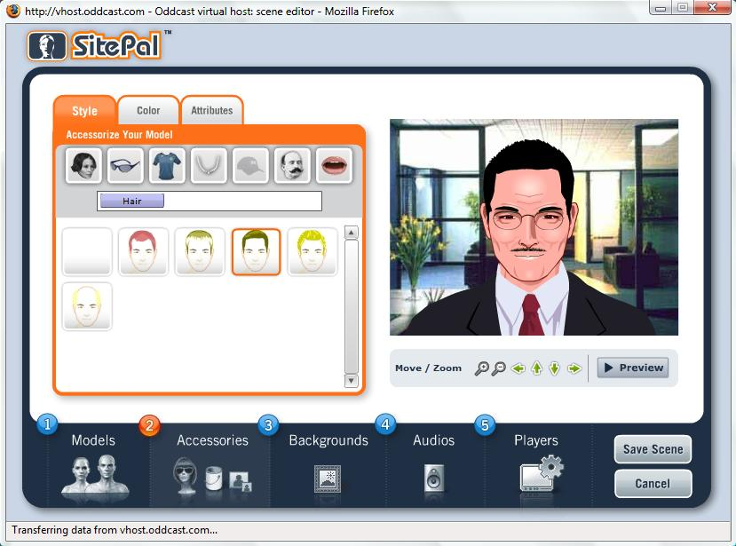
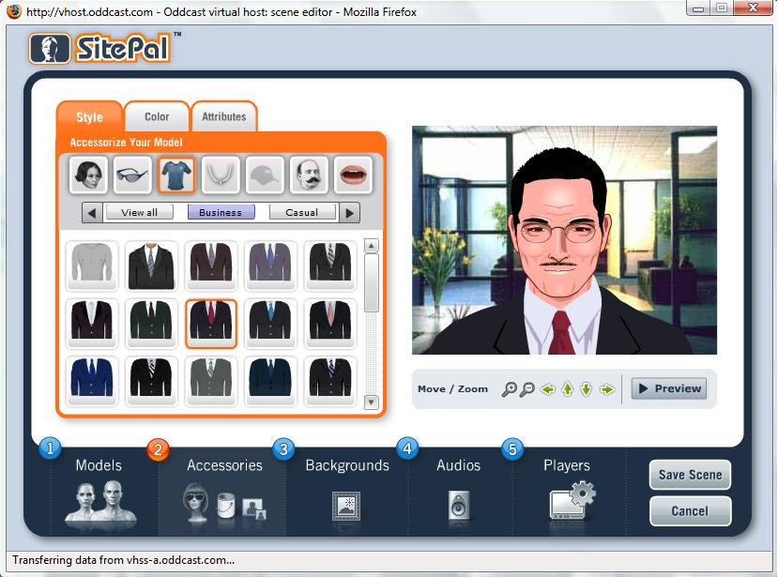

Figure 4. A screen display of the Design & Development Platform of Pedagogical Agents (www.sitepal.com)

Figure 5 shows the development of six PAs that represent specific instructional roles.


PAs with Instructional Roles
Professor/Lecturer
(Expert)
Tutor/Facilitator
(Mentor)
Peer/Learning Companion
(Motivator)
Professor Adam
Dr. Susan
Mr. Eric
Miss Venessa
Hazwan
Sarah

Figure 5: Images pepresenting instructional roles of Pedagogical Agents

In the forties, the images of PAs with the instructional role of an expert were designed with the appearance of a professor or lecturer and they were referred to as “Professor Adam” and “Dr. Susan”. They were formally dressed and set with limited gestures. As for the images of mentors, “Mr. Eric” and “Miss Venessa” were designed with the appearance of a tutor or facilitator in semi-formal attire. The appearances showsyoung and mature tutors with the age ranging from 25 to 35 years old. They were designed to show and represent the combination of expert and motivator.

The images of motivator agents were set to the appearances of college or university students in the twenties, as the sample of the study was a group of university students. This was to create the images of peers or learning companions for the sample. The PAs were casually dressed and were referred to as “Hazwan” and “Sarah”.

Scripts for the Pedagogical Agents
By applying the personalisation principle in the applications of PAs, the scripts of the agents had to be presented in a conversational style to promote better learning and motivational outcomes. Figure 6 below shows an example of the formal and personalised versions of an introductory script of a research study conducted by Moreno and Mayer (2000).

Introductory Portion of Text Spoken in
a Computer-Based Educational Game on Botany
Formal Version
This program is about what type of plants survives on different planets. For each planet, a plant will be designed. The goal is to learn what type of roots, stem, and leaves allow the plant to survive in each environment. Some hints are provided throughout the program.
Personalized Version
You are about to start a journey where you will be visiting different planets. For each planet, you will need to design a plant. Your mission is to learn what type of roots, stem, and leaves will allow your plant to survive in each environment. I will be guiding you through by giving out some hints.

Figure 6. A formal versus a personalised lesson introduction

In this study, the scripts were also formulated with a conversational style based on the personalisation principle. Three versions of a personalised script were written to represent the way the agents spoke in different roles (refer to Figure 7). The length and content of the scripts were almost the same. The script of the professor or lecturer was written in a way to present accurate and timely information. On the other hand, the script of the peer or learning companion was set to give encouragement and motivation to engage the involvement of the learners in the learning environment. The role of the mentor was the combination of both expert and motivator; this script was meant to give information, guidance and encouragement to the learners.

Introductory Scripts of the PAs based on Instructional Roles
Professor/Lecturer (Expert)
Hello there! I am Adam. In this session, I will introduce to you briefly about pedagogical agent. Actually, pedagogical agents are life-like characters or virtual avatars, which are designed to facilitate learning in a computer learning environment. Agents can be built utilizing the virtual reality and artificial intelligence technologies. Hope you could learn more effectively, with the help of pedagogical agents.
Peer/Learning Companion (Motivator)
Hi! How are you?! I am Hazwan! I am so glad to meet you today! So, do you like to know more about pedagogical agents? Well, you do look investigative. Actually, I am one of the agents! We are created to assist you in your learning in this computer environment! Yeah, I know we can do well together! I hope that we will know each other better and I’ll be your excellent learning companion! See you later!

Tutor/Facilitator (Mentor)
Hello! Welcome to this new learning environment! I am Eric, and I will facilitate you to know more about pedagogical agents. Pedagogical agents are life-like characters or virtual avatars just like me! We are designed to help you learn better in this computer environment. Well, as you are so investigative, why not you look for more information in the official SitePal website, or the official Media Semantics website! Anyway, you may talk to me if you have any doubts. All the best and nice meeting you!

Figure 7: Examples of introductory scripts for Pedagogical Agents
based on instructional roles

METHODOLOGY
This preliminary study was carried out to validate the role of the developed PAs in terms of the instructional roles they played. Two aspects of validation were carried out in this preliminary study. Firstly, the images of the agents were validated for their appearance to represent their instructional roles correctly. Secondly, the scripts of the agents were validated for their purpose and role.

A total of 50 undergraduate students from Universiti Sains Malaysia participated in this validation study. The sample consists of 30% male and 70% female students. The average age of the sample was 23.86 (SD=2.424). The sample presented the six images of the developed PAs (refer to Figure 6). Based on the images they observed, the students were required to identify the instructional roles played by the PAs, that is, whether the appearance of the image looked like that of a “professor/lecturer”, “peer/learning companion” or “mentor/facilitator”.

In the validation study of the scripts, the sample was presented with three versions of the script presentation entitled “Introduction to Animated Pedagogical Agents”. The evaluation by the students took about three minutes. Subsequently, the students were required to identify whether the script sounded “informative”, “motivating” or “informative and motivating”.

RESULTS AND DISCUSSION
Table 1 shows the percentages of learners who identified the intended instructional roles of the pedagogical agents in terms of their images and Table 2 shows the percentages of learners indentifying the instructional roles in terms of the scripts.

Table 1. Percentages of learners voting for agents' instructional roles in terms of images
Image of Agent  (Intended Instructional Roles) | Image | Percentage (%) of Learners Voting on  Agent’s Instructional Role
Image of Agent  (Intended Instructional Roles) | Image | Professor/Lecturer | Tutor/Facilitator | Peer/Learning Companion
Image 1: Adam  (Professor/Lecturer) |  | 82.0% | 14.0% | 4.0%
Image 2: Susan  (Professor/Lecturer) |  | 84.0% | 12.0% | 4.0%
Image 3: Eric  (Tutor/Facilitator) |  | 0% | 48.0% | 52.0%
Image 4: Venessa  (Tutor/Facilitator) |  | 40.0% | 46.0% | 14.0%
Image 5: Hazwan  (Peer/Learning Companion) |  | 0% | 20.0% | 80.0%
Image 6: Sarah  (Peer/Learning Companion) |  | 0% | 26.0% | 74.0%

Table 2. Percentages of learners responding to instructional roles in terms of scripts
Presentation of PA  (Intended Purpose) | Percentage (%) of Learners Voting on  Purpose of the Script
Presentation of PA  (Intended Purpose) | Informative | Motivating | Informative & Motivating
Presentation 1: Adam  (Informative) | 74.0% | 4.0% | 22.0%
Presentation 2: Hazwan  (Motivating) | 30.0% | 44.0% | 26.0%
Presentation 3: Eric  (Informative and Motivating) | 12.0% | 22.0% | 66.0%

For the image validation study, the results revealed that the learners’ perception on the instructional role of images 1, 2, 4, 5 and 6 conformed to the intended roles indicated by the design of the images. Image 3 did not, however, effectively show the appearance of a tutor or facilitator. A possible reason for the slightly different result is likely due to the appearance of the sample’s average age. The appearance of image 3 might have looked too young and most likely that of the image of a university or college student. As the mean age of the sample stated was 23.86, image 3 appeared as a peer to the sample. The appearance and attire have to be changed to a more formal appearance to improve the image to effectively show that of a mentor agent.

As for the script validation study, the results revealed that the students’ perception towards the three versions of presentations corresponded to the purpose the scripts were intended for. This preliminary study revealed that the PAs played significant roles in the learning of the students. According to the feedback given by the learners, they gained more detailed information from Adam’s presentation (informative), but learning was more fun, interesting and informative when they learned from Eric (informative and motivating).

CONCLUSION
This study found that in general, the PAs with instructional roles were effectively developed and empirically validated. The agents were also successfully integrated in the Moodle open source LMS that represents a new instructional method in e-learning. However, further research and implementing this study on different samples have to be undertaken, as learners of different ages and backgrounds may have different perceptions on agent roles.

REFERENCES
Alias, N. A., & Zainuddin, A. M. (2005). Innovation for Better Teaching and Learning: Adopting the Learning Management System. Malaysian Online Journal of Instructional Technology, 2(2), 27-49.
Baylor, A. L. (1999). Intelligent Agents as Cognitive Tools for Education. Educational Technology, 39(2), 36-40.
Baylor, A. L. (2000). Beyond Butlers: Intelligent Agents as Mentors. Journal of Educational Computing Research, 22(4), 373-382.
Baylor, A. L. (2005). The Impact of Pedagogical Agent Image on Affective Outcomes. Paper presented at the Workshop “Affective Interactions: The Computer in the Affective Loop” at the International Conference on Intelligent User Interfaces, San Diego, CA.
Baylor, A. L., & Kim, Y. (2003, June). Validating Pedagogical Agent Roles: Expert, Motivator, and Mentor. Paper presented at the ED-MEDIA 2003, Honolulu, Hawaii.
Baylor, A. L., & Kim, Y. (2004). Pedagogical Agent Design: The Impact of Agent Realism, Gender, Ethnicity, and Instructional Role. Paper presented at the Workshop on "Social and Emotional Intelligence in Learning Environments," held at the International Conference on Intelligent Tutoring Systems, Maceió, Brazil.
Bloom, B. S. (1984). The 2 Sigma Problem: The Search for Methods of Group Instructionas Effective as One-to-One Tutoring. Educational Researcher 13, 4-16.
Chen, W., Mørch, A., & Wasson, B. (2002). Pedagogical Agent Design for Distributed Collaborative Learning. Paper presented at the International Conference on Computers in Education (ICCE2002), Auckland, New Zealand.
Clark, R. C., & Mayer, R. E. (2003). e-Learning and the Science of Instruction: Proven Guideliness for Consumers and Designers of Multimedia Learning (1 ed.). San Francisco, CA: Jossey-Bass/Pfeiffer.
Craig, S. D., Gholson, B., & Driscoll, D. M. (2002). Animated Pedagogical Agents in Multimedia Educational Environments: Effects of Agent Properties, Picture Features, and Redundancy. Journal of Educational Psychology 2002, 94(2), 428-434.
Johnson, W. L., & Rickel, J. W. (2000). Animated Pedagogical Agent: Face-to-Face Interaction in Interactive Learning Environments. International Journal of Artificial Intelligence in Education 2000, 11, 47-78.
Kim, Y. (2005). Pedagogical Agents as Learning Companions: Building Social Relations with Learners. In C. K. Looi (Ed.), Artificial Intelligence in Education: Learning through Intelligent and Socially Informed Technology (pp. 362-369). Amsterdam: IOS Press.
Lester, J. C., Voerman, J. L., Towns, S. G., & Callaway, C. B. (1997, August). Cosmo: A Life-like Animated Pedagogical Agent with Deictic Believability. Paper presented at the IJCAI'97 Workshop on Animated Interface Agents: Making Them Intelligent, Nagoya, Japan.
Moreno, R., & Mayer, R. E. (2000). Engaging Students in Acive Learning: The Case for Personalized Multimedia Messages. Journal of Educational Psychology, 93, 724-733.
Moreno, R., Mayer, R. E., Spires, H., & Lester, J. (2001). The Case for Social Agency in Computer-Based Teaching: Do Students Learn More Deeply When They Interact With Animated Pedagogical Agents? Cognition and Instruction, 19, 177-214.
Rickel, J., & Johnson, W. L. (2000). Task-Oriented Collaboration With Embodied Agents in Virtual Worlds.

