e-learning research and development experiences related to learning
computer science, information technology and multimedia subjects

by

Baharuddin Aris
Mohamad Bilal Ali
Jamalludin Harun
Zaidatun Tasir
Noor Azean Atan
Norah Md. Noor

Department of Educational Multimedia
Faculty of Education
Universiti Teknologi Malaysia

Abstract

Lecturers in the Faculty of Education at Universiti Teknologi Malaysia (UTM) first developed Internet-based subject since 1997. The first Internet-based subject that was developed in the Faculty of Education is “Computer Literacy”. It was developed using html coding. This paper will attempt to describe a brief history of e-learning and evolution of e-learning at UTM as well as problems encountered and solutions to these problems. Examples of e-learning research and development experiences at UTM will also be described in this paper.

Introduction

The Faculty of Education at UTM not only offers a curriculum to educate teachers from different major field of studies, such as Sports Science, Islamic Studies, TESL, Mathematics, Science and Technical, related to computer science, information technology and multimedia subjects but also provide real-life learning experiences in using information and communication technology (ICT). This is because the successful use of ICT in schools requires the teachers themselves to be familiar with - and competent in the use of - such technology (Baharuddin Aris et al., 1999).

From the literature search, it can be generalized that research studies related to computer science education that is learning computer science, information technology and multimedia subjects, are still very much an emerging field of study. Indeed, very few studies have been conducted with regard to the process of learning computer science, information technology and multimedia subjects and learning computer science, information technology and multimedia subjects using computer-based learning materials. For example, a few research related to computer science education research include students learning about the concept of an information systems (Cope, 2000), students learning about the concept of computer systems (Berglund, 2005), students learning about computer systems using an interactive multimedia package (Baharuddin Aris et al., 1998; Baharuddin Aris, 1999) and students learning about multimedia technology on the Web (Jamalludin Harun, 2003).

Brief History of E-learning at UTM

The lecturers in the Faculty of Education at UTM have begun developing e-learning portals as early as 1997. The first Internet-based course is a “Computer Literacy” course which can be access through CyberDidik; http://161.139.52.251. It was developed using html coding (Baharuddin Aris, 2001). Normally, UTM teacher-education students will study the course based on traditional lectures. The traditional lectures were later supplemented with on-line, full and complete lecture notes. These notes were provided free of charge for students’ reference while they were on campus. At first the complete lecture notes were delivered over the Internet. Unfortunately, the notes were digitally copied, printed out as modules and later sold to students by some lecturers.

Only a small number of UTM teacher education students know how to zip a file. Surprisingly, out of this few, not many students know how to use the zip software, such as WinZip. Thus, in 2001, an effort has been taken to help students learn about and using the WinZip via a written module and the Web. Initial interview by Baharuddin Aris with the students who used such medium in learning about and using WinZip, many showed positive attitudes toward the use of the Web as a learning tool. However, findings also reported that a few students were discontent with having to go to an Internet! In general, they commented that, “Internet-based learning is only meant for the elite group”.

In second semester 2001/2002 session, UTM implement Web-CT version 3.5 plus a Document Publishing and Management System (DPMS) by Harvest Road as their e-learning management system. DPMS allows teachers to store and manage learning resources using a variety of formats such as Word documents, images, music and audio files, web pages, spreadsheets, video and streaming video. Each resource is accessible in on the web pages created in WebCT and immediately accessible to students. In this way teachers can update and edit documents in DPMS without disrupting student access to course materials. Several e-learning materials related to learning computer science, information technology and multimedia produced can be access via http://webct.utm.my. For example, see Figure 1.

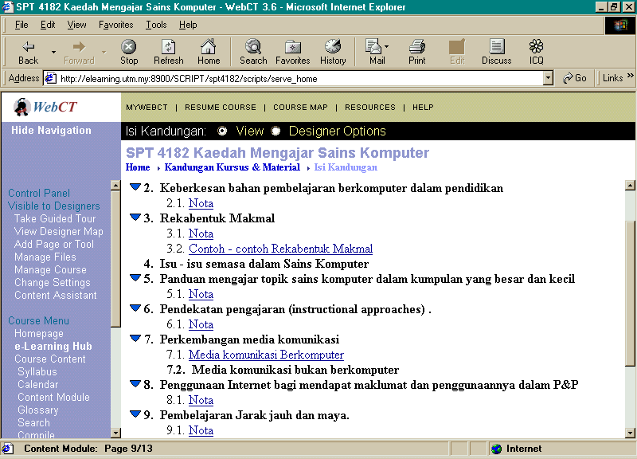
Figure 1: SPT 4182 Methods of Teaching Computer Science

Selected staffs which had good background in computer application and HTML coding, find it quiet easy to follow. It was such a thrilling experience when course resources can be easily accessible online and available at any time and from anywhere. Apart from that, WebCT provides opportunities such as students can collaborate with peers, mentors and teachers through collaborative tools such as discussion forums, chat, whiteboard and email.

UTM encouraged its lecturers to publish their notes in e-learning portals for students’ references while they were on campus. Unfortunately, as it was only available in the local network, students who stay outside campus cannot download the notes provided.

The processes of sharing knowledge on how to use it with other colleague who had only minimum experience using computer were quite challenging. The hardest part was to create a hyperlink on the WebCT for the note that we load in the DPMS. The complaint was too many steps involve. They had to load the note in DPMS, create space in the WebCT, create hyperlink in the DPMS and then copied it back in the WebCT. This cause those to just upload it once and then leave it there until end of the semester.

The other downturn for using it as the e-learning tool was, WebCT files must be in html format. Well, we can just us any html editors such as Dreamweaver, Netscape Composer or PageMill to create your web page and then import the file into WebCT. However, for those with minimum background in computer application will find it hard to maintain.

Apart from some of this hiccups, WebCT and DPMS advantages such as its system supports which available whenever technical difficulties happen made UTM to continue using it. However, starting from 2nd semester 2004/2005 session, UTM decided to change into open source application which is Moodle (see Figure 2) as a new e-learning management system cause by a few reasons that will be discussed later.
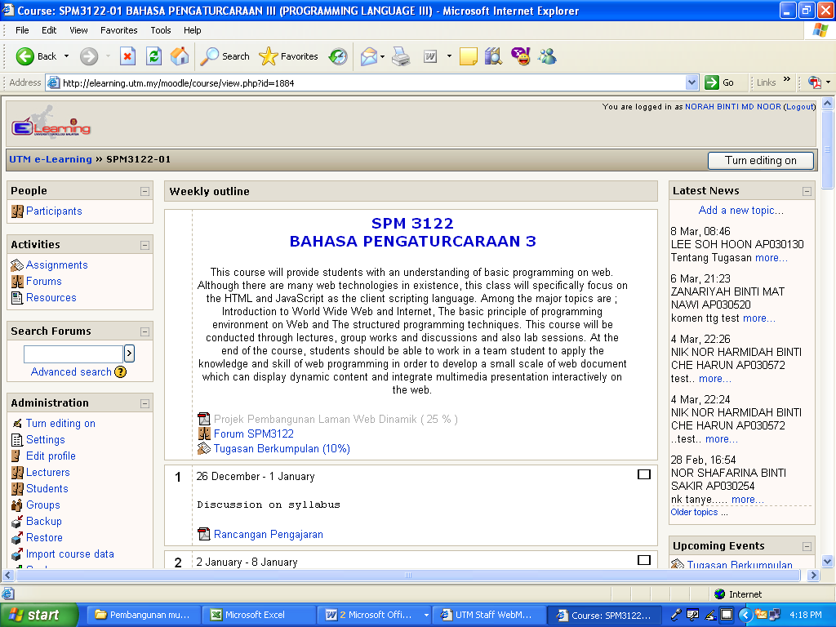
Figure 2: SPM 3122 Programming Language 3 in e-learning using Moodle

Evolution of e-learning at UTM

Year | Web server | Hardware | Operating system | Development software
1997 | IIS | Non branded and ordinary desktop | Windows NT | Html coding using notepad
1998 | IIS | Branded server with single processor | Windows NT | MS Frontpage, Adobe Photoshop
2001 | WebCT & Harvest Road | Sun | Solaris | MS Frontpage, Adobe Photoshop, Sound Forge, Macromedia Flash, Powerpoint, MS Word.
2004 | Moodle | 2 Branded server with dual processor with 4GB and 2GB RAM | LINUX | MS Frontpage, Adobe Photoshop, Sound Forge, Macromedia Flash, MS Powerpoint, MS Word and standard multimedia elements.

Table 1: Evolution of e-learning system at UTM

Table 1 shows the evolution of e-learning system at UTM. The emphasis is on the hardware and software aspect of e-learning initiatives at UTM.

There several reasons why UTM migrated to open source based system. Here are the main reasons:

- Financial stability
WebCT require UTM to pay yearly license fees. We feel that we can save this money for other things.
- Customization
UTM need to customize the e-learning system to meet the requirement of our students, lecturers and administrator. In order to do that we had to have strong and knowledgeable supporting team. At the moment our customization were developed by our supporting team and students through course projects.

- Ease-of-use
Comments from users, WebCT are not designed for layman. Users need to have some html coding skill and knowledge before they effectively use the system. For instant, linkages from WebCT to database were not transparent and involved complicated procedure.

Higher-ed Learning Management System (LMS) market penetration: Moodle vs. Blackboard+WebCT vs. Sakai

- Moodle: 2,981 deployments / 54% market share
- Blackboard + WebCT: 2,500 deployments / 45% market share
- Sakai: 35 deployments / 0.63% market share
Note: Taken from the Sakai partners page.
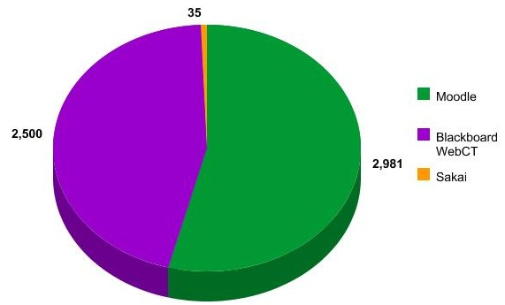
Figure 3: Current market penetration on Moodle, Blackboard+WebCT and Sakai.

How to support open source system?

Proper setting in human resource and distributed system is a vital. We need to get support from various parties from top administrator to a technician level. They/The centers are Deputy Vice Chancellor (Academic) or DVC(A), Faculty, Centre of Teaching and Learning(CTL), Center of Information and Communication Technology (CICT), Information Technology Manager (IT Manager), Deputy Dean and System analysts team (SA Team). E-learning also needs to be a part of our system and must be at all levels. Figure 4 shows UTM organization chart of e-learning support system.

Figure 4: Flow chart e-learning support system.

How to choose the right LMS for our institutions?

This is a question that has to be answered by groups of staffs not by one administrator. Remember; don’t just select a LMS simply based on the success of its used in other companies or institutions. This is because different institutions have different needs and settings of teaching and learning. Therefore, selecting a right LMS has to consider many factors including institution budget, culture and structure, types of learning programs, numbers of learning programs, types of students and other factors that are related to learning.

According to Alvarado (2004), LMS selection process involves a seven-step process as the following:

- Determine the learning strategies
- Prepare the document requirement of LMS
- Research LMS companies
- Request a proposal from the LMS companies
- Review the proposal
- Schedule meetings and demos
- Make the selection

The seven-step process requires your institution to spend its time and sometimes some amounts of money before the right LMS can be selected. However, it is worth because the process of selecting LMS is very important. Remember, switching to another LMS from the one that your institution had bought will cost more. Therefore the high cost of switching LMSs makes customers more loyal even when they’re dissatisfied with certain elements of their LMS." It’s best to make every effort to find the right system the first time around; easier said than done.

In choosing the right LMS for your institution, our suggestions are to choose:

- a LMS that has a reasonable cost; appropriate with your institution budget. If you can get an open-source LMS, go for it and try it first.
- a LMS that easy to use and has a friendly interface.
- a LMS that is flexible enough; can be manipulated based on students’ learning styles.
- suitable for all kinds of discipline such as Engineering, Sciences, Social Sciences and others.

Related research towards e-learning initiatives

Various research related to e-learning application in schools or higher education have been done either to see whether its helps enhancing the student performance or just to look at the problem arise (Stanfield et al., 2004, Mohd Fadzli Ali et al., 2005 , Zaidatun Tasir et al., 2005a).

School of Computing at the University of Paisley offer two (2) online programs called MSc Management of eBusiness and MSc IT with Web Technology since 2001. (Stanfield et al., 2004) illustrate that handling an online courses was quite difficult as teachers cannot hear, observe or interpret their student facial expressions immediately. However, using learning management system that provide facilities to collaborate with others and interactions with the learning material give flexibility to the student to access and learn on their own pace.

(Stanfield et al., 2004) also shows that 4 of their modules from MSc Program which were taught in both face-to-face (F2F) and online delivery modes (with its distinctive educational process) by the same teacher illustrate that the online students performed consistently better than both the full-time and the part-time F2F student. The school even decided that the part-time F2F students to be taught in the online format.

Universiti Technologi Malaysia adopted an open source learning management system (LMS) called Moodle by 2004. This LMS was based on a learner-oriented philosophy which promoted social constructionist pedagogy which mean that students were involved in constructing their own knowledge and share it with their colleague (critical reflections). (Mohd Nihra Haruzuan Mohd Said et al., 2005).This was proved by looking at the finding made by Mohd Fadzli Ali et al. (2005) which shows that 203 students who registered for subject SPT 4322 posted a total number of 856 messages. The facilities to discuss asynchronously with each other have captured the initial enthusiasm of the students and played a significant part in the socialization process and subsequently in the creation of a community of learners.

From the database of e-learning usage by UTM students, it had been recorded that the accession number of eight (8) top ten subjects within 3 months Moodle were being introduces surprisingly at 313,601. From the research that has been conducted, this response was excessive compared to the previous version of learning management system being used by the organization based on a few strategies that being used by the lecturer. One of the strategies is to always update the information online and not just uploading the learning materials (Zaidatun Tasir et al., 2005a).

(Zaidatun Tasir et al., 2005b) shows that e-learning tools such as electronic forum, chatting and electronic journal help the process of implementing Problem Based Learning (PBL) strategy. It helps to farther the discussion among student and students and between students and a lecturer outside the classroom. The finding also illustrate that students feel the use of PBL through e-learning is relevant to their studies and future work.

Currently, there are still a few ongoing researches done by our group in Universiti Teknologi Malaysia. One of the ongoing researches is to identify which factors that influence students to use e-learning, problem occur while using e-learning, and pro and cons of current e-learning in UTM. There are six factors that this research focus on towards using e-learning, which are learning content, student’s initiatives, lecturer initiatives, the usefulness, the ease-of-use and e-learning design.

Another ongoing research is done by Center of Teaching and Learning in Universiti Teknologi Malaysia regarding student’s perception towards e-learning using Moodle”. The analysis and finding for both researches will be presented in future conferences.

References

Alvarado, P. (2004). Seven Steps to Selecting a Learning Management System. http://www.clomedia.com/ [Online]
Baharuddin Aris, Mohd Salleh Abu, Ellington, H. I. and Dhamotharan, M. (1998). Producing interactive multimedia courseware for Information Technology in education : an initiative at Universiti Teknologi Malaysia. Journal of Instruction Delivery System, 12 (3). 31-37.
Baharuddin Aris, Mohd Salleh Abu, Ellington, H. I. and Dhamotharan, M (1999). Integrating multimedia technology in the curriculum : Universiti Teknologi Malaysia’s experiences. Innotech Journal, Vol. 23, No. 2, July to December.
Baharuddin Aris (1999). The use of information technology in education: using an interactive multimedia courseware package to upgrade teachers’ knowledge and change their attitudes. Unpublished Ph.D. Thesis, The Robert Gordon University, Aberdeen, Scotland.
Baharuddin Aris (2001). Universiti Teknologi Malaysia’s teacher education students learning about ICT using ICT. Innotech Journal, Vol. 25, No. 2, July to December.
Berglund, A. (2005). Learning computer systems in a distributed project course: The what, why, how and where. Unpublished Ph.D. Thesis, Uppsala University, Uppsala, Sweden.
Cope. C. (2000). Educationally critical aspects of the experience of learning about the concept of information system. Unpublished Ph.D. Thesis, La Trobe University, Bundoora, Victoria, Australia.
Jamalludin Harun (2003). Pembinaan dan Penilaian Keberkesanan Sistem pembelajaran Berasaskan Masalah Menerusi Web Bagi Program Perguruan. Unpublished Ph.D. Thesis, Universiti Teknologi Malaysia, Skudai, Johor,
Stanfield, M., McLellan, E. and Connolly, T. (2004). Enhancing Student Performance in Online Learning and Traditional Face-to-Face Class Delivery, Journal of Information Technology Education, Volume 3, 2004, 173-188.
Mohd Nihra Haruzuan Mohd Said, Mohd Fadzli bin Ali, Rosni Zamuddin Shah Sidek and Norah Md Noor. (2005). The Application of E-learning in Supporting Teaching and Learning : An Overview, 3rd International Seminar on Learning and Motivation “Enhancing Student Engagement”, 10-12 September 2005, Langkawi, Malaysia.
Mohd Fadzli Ali, Zaidatun Tasir, Baharuddin Aris and Mohd Nihra Haruzuan Mohd Said (2005). Developing an Effective Collaborative E-Learning in Complementing Traditional Face-To-Face Learning Environment in UTM, International Symposium on E-Learning 2005, 25-26 July 2005, UMS Sabah, Malaysia.
Zaidatun Tasir, Jamaluddin Harun, Mohd Fadzli Ali, Baharuddin Aris and Mohd Nihra Haruzuan Mohd Said (2005a). The Use of E-Learning in Universiti Teknologi Malaysia : Effective Strategies That Have Been Identified, International Symposium on E-Learning 2005, 25-26 July 2005, UMS Sabah, Malaysia.
Zaidatun Tasir, Jamaluddin Harun and Norah Md Noor. (2005b). Problem-Based Learning and e-Learning : A Case Study in Faculty of Education, Universiti Teknologi Malaysia, International Symposium on E-Learning 2005, 25-26 July 2005, UMS Sabah, Malaysia.

Brief Background of Writers

Assoc. Prof. Dr. Baharuddin Aris is Head of Department of Educational Multimedia, Faculty of Education, UTM, Skudai, Johor, Malaysia; Assoc. Prof. Mohamad Bilal Ali was an Information Technology Manager and currently pursuing his Ph.D. related to computer science education research; Dr. Jamalludin Harun is Information Technology Manager, Centre for Teaching and Learning, UTM, Skudai, Johor, Malaysia; Dr. Zaidatun Tasir is Information Technology Manager, Faculty of Education, UTM, Skudai, Johor, Malaysia; Mrs. Noor Azean Atan is Program Coordinator, Department of Educational Multimedia, Faculty of Education, UTM, Skudai, Johor, Malaysia; Mrs. Norah Md. Noor is Program Coordinator, Department of Educational Multimedia, Faculty of Education, UTM, Skudai, Johor, Malaysia.

