Multi-touch Screen Table For Collaborative Classroom
SALIHUDDIN BIN MD SUHADI
IRWAN SHAH BIN MOHD. GHANNY
Introduction
Definition of multitouch screen
Multi-touch (or multitouch) denotes a set of interaction techniques which allow computer users to control graphical applications with several fingers.
Multi-touch consists of a touch screen (screen, table, wall, etc.) or touchpad, as well as software that recognizes multiple simultaneous touch points, as opposed to the standard touchscreen (e.g. computer touchpad, ATM), which recognizes only one touch point. This effect is achieved through a variety of means, including but not limited to: heat, finger pressure, high capture rate cameras, infrared light, optic capture, tuned electromagnetic induction, ultrasonic receivers, transducer microphones, laser rangefinders, and shadow capture.
Many applications for multi-touch interfaces exist and are being proposed. Multi-touch is often associated with Apple Inc's iPhone and iPod Touch but is also used in many other products such as Apple's MacBook and MacBook Pro notebook line. Other products with multi-touch technology include Microsoft Surface, Asus EEE PC, and Meizu M8.
Multi touch controllers these days support Single-Touch and Multi-Touch All-Point touchscreen applications which allow functions such as playing video games on a mobile handset,using GPS to key in multiple locations etc.
Collaboration(denote for collaborative)
Collaboration is a recursive process where two or more people or organizations work together toward an intersection of common goals for example, an intellectual endeavor that is creative in nature by sharing knowledge, learning and building consensus. Collaboration does not require leadership and can sometimes bring better results through decentralization and egalitarianism. In particular, teams that work collaboratively can obtain greater resources, recognition and reward when facing competition for finite resources. Collaboration is also present in opposing goals exhibiting the notion of adversarial collaboration, though this notion is atypical of the annotation that people have given towards their understanding of collaboration.
Structured methods of collaboration encourage introspection of behavior and communication. These methods specifically aim to increase the success of teams as they engage in collaborative problem solving. Forms, rubrics, charts and graphs are useful in these situations to objectively document personal traits with the goal of improving performance in current and future projects.
Since the Second World War the term "Collaboration" acquired a very negative meaning as referring to persons and groups which help a foreign occupier of their country due to actual use by people in European countries who worked with and for the Nazi German occupiers. Linguistically, "collaboration" implies more or less equal partners who work together which is obviously not the case when one party is an army of occupation and the other are people of the occupied country living under the power of this army.
In order to make a distinction, the more specific term "Collaborationism" is often used for this phenomenon of collaboration with an occupying army. However, there is no water-tight distinction; "Collaboration" and "Collaborator", as well as "Collaborationism" and "Collaborationist", are often used in this pejorative sense and even more so, the equivalent terms in French and other languages spoken in countries which experienced direct Nazi occupation.
Relationship about the multitouch and collaborative
For a nowadays, interactive teaching and learning are so important for our generation. The multitouch screen table(smart table) and collaborative learning are the one of the solution related with the problem.
With the smart table, the student can discuss anything about any subject because the table are connected with internet where they can search anything they can’t understood about certain subject on the web.
Problem statement
We discuss about the severel problem related with the topic. Some of the problem are :-
- Not enough illumination in the classroom- so the student difficult to see screen or white board in front of class
- The classroom arrangement – student are sitting in group, so that they are difficult to see anything happen in front there
- Student sit back to back the screen is causes they can not to bother and playing with friend.
With the problem, the T&L objective were not be achieve after the T&L process.
Objective this product
The objective for this product is :-
- To avoid the boredom student when they in learning process
- To give more interactive material for student that want interesting learning
- To facilitate teacher and student during T&L
Importance for this product
The importance of the study basicly is the :-
- To achieved the objective for the collaborative T&L
- To enactive the student pay attention when the T&L is running
- To save cost longest time when we use the Smart table. The price is about 5,000 USD
But the most important thing is to achieved the objective for T&L.
The goal for this product
We target for this product is:-
- want to give alternative way for certain teacher and student for more interested in learning
- to produced more excelent student parallel with “PIPP”
- The user can use the smart table for longer time and save the budget.
The advantage using these smart tables
With using this smart table is:-
- make students free to discuss about the topic that teacher gives, all the discussion, drawing and anything can be save in a pendrive and can be continue in the next class
- the cost also vuldarable that the smart tables can be used for a long time and repeatable
- the data, picture can be transferred easily as we put the medium on the smart tables and the transferred will transfer automatically
- The smart tables also connected to the live internet so the students can browse whatever they want in the discussion.
The Feature of Smart Table
- The Shape easy to sit and the picture can be encircle 360º
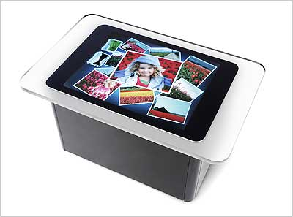
- Easy to discuss- every face can look

- Teacher or monitor can show the method in front of class with the networking.
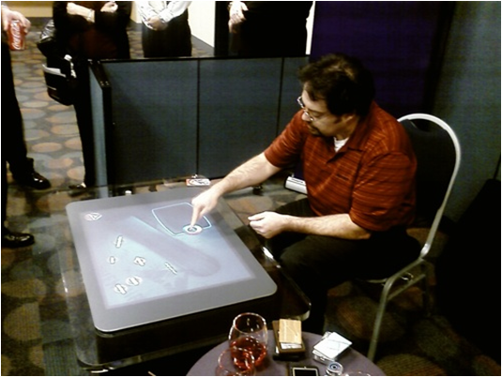
- Save time for T&L

- This table is outward appearance hand-on where it is good for child mind
- All student that the table are involved in T&L
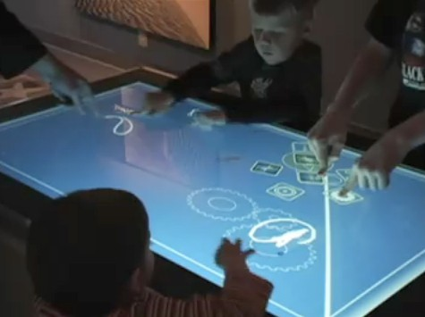

- This table also can lay down in home for family user
- It is can be used although the user in relaxing time
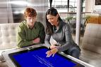

Conclusion
- Student achievement can be increase with the using smart table during T&L
- To attract the student attention when the teacher teach about something that very boring subject
- Must be use that table for the technologies generation concord the year 2020 insight

Reference
http://readyset.tigris.org/nonav/templates/proposal.html
http://www.eee.metu.edu.tr/~design/proposal.htm
http://www.idrc.ca/en/ev-57070-201-1-DO_TOPIC.html#timetable
http://tutorialblog.org/writing-a-project-proposal/
http://expocad.1105web.com/fetc/Data/EC/Event/Exhibitors/238/productPhoto1.jpg
http://en.wikipedia.org/w/index.php?title=Special%3ASearch&search=smart+table&fulltext=Search
http://www.technologyreview.com/blog/editors/17612/

