SSCM 1313
C++ COMPUTER PROGRAMMING

Chapter 6:
Class, Object and Function

Authors:
Farhana Johar
Professor Dr. Shaharuddin Salleh

Class, Object and Function

Object-oriented approach:
Function. Classes and their objects, Constructor/ destructor and function overloading. Inheritance, class collaboration and polymorphism. Dynamic memory allocation. Applications in graph theoretical and matrix problems.

C++ Language Organization

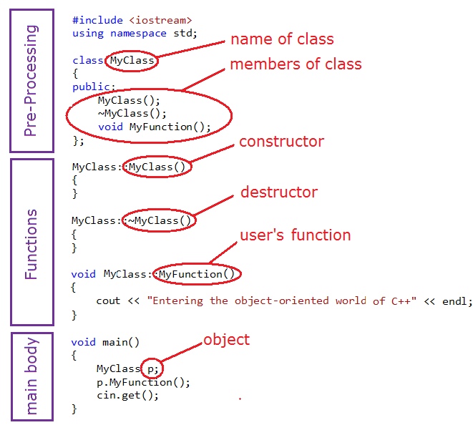

Figure 6.1. Order of execution in a typical C++ program.

Class
- a grouping of variables and functions that have a common ancestor
- a special form of structure
- object is an instance of a class
- members of a class consist of variables, functions and structures, which are global

class Name of Class
{
private:
List of variables
public:
List of variables and functions
};

Example:

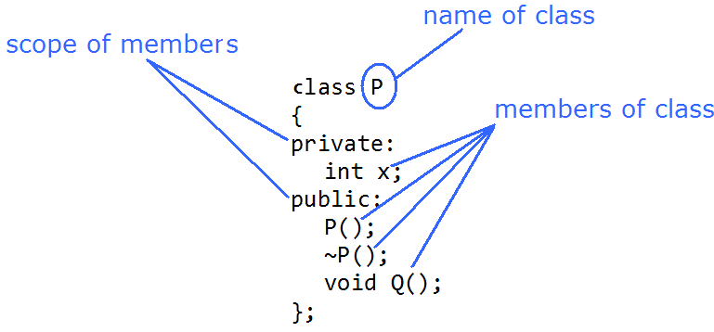
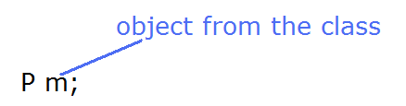

Visibility of Members

- Members of a class are variables, structures and functions
- Each member are global, and its scope is either private or public

 private
- for variables or structures only
- the scope is global but limited to member functions only

 public
- for variables, structures and functions
- The scope covers the whole program including non-member functions

Function

- a module or one unit of work in a program that can be called for solving a given problem
- Needed in order to make the program structured and modular
- A function must have a name.
- A function must belong and declared into a class.
- A function must be a prototype from one of the followings
void
int
float
double
char
bool
- A function of type other than void must return a value, and its return value is received by a variable from another function.
- A function may include argument(s) for passing or receiving data to another function.

Example:
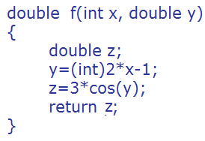

Special Functions

 Constructor
- A special function which has the same name as the class
- a function with no specific class
- allocates memory for the class
- a suitable place for initializing global variables

 Destructor
- a special function which has the same name as the class preceded with a tilde
- a function with no specific class
- deallocates memory from the class
- a suitable place for destroying global variables and arrays
 Code6A.cpp: Class and object.
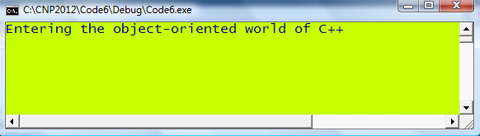

 Code6B.cpp: Class, object and method.
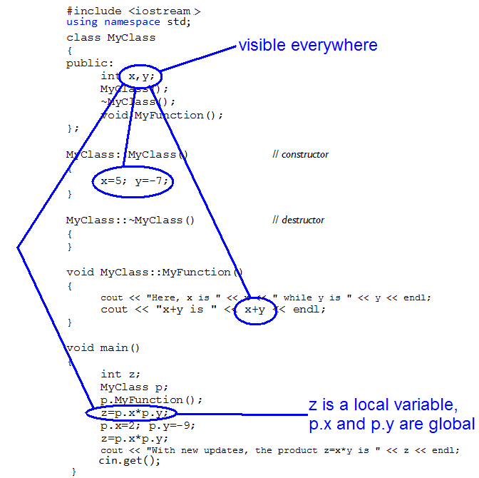
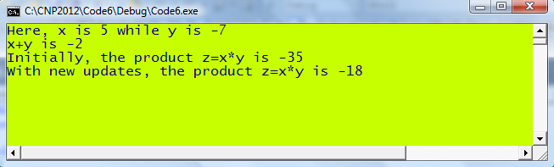

 Code6C.cpp: Class construction.
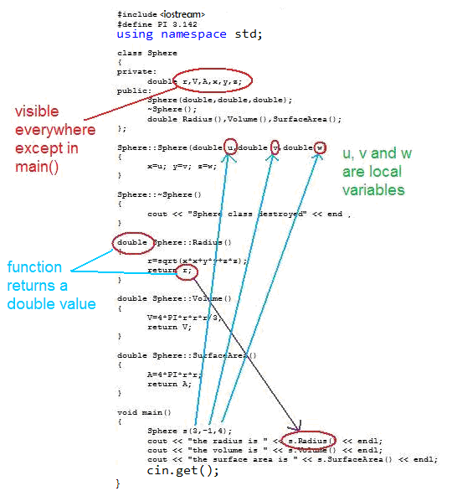
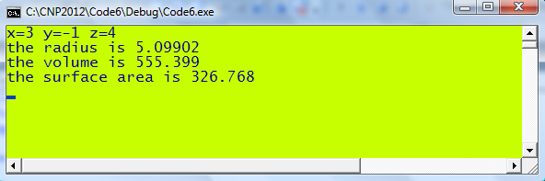

 Code6D.cpp: Class construction in a compact form.
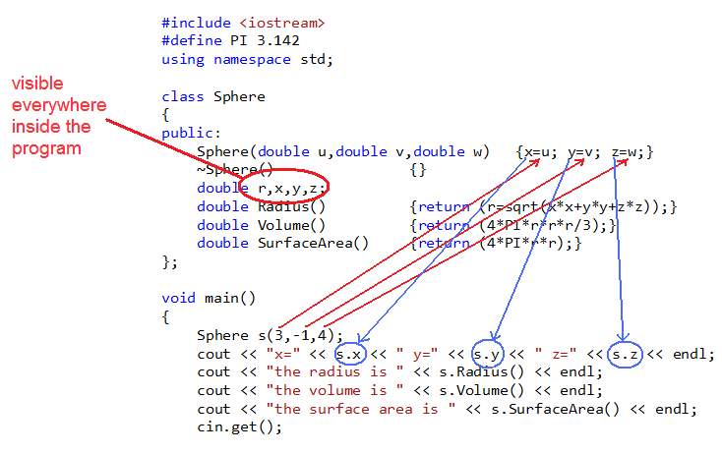

Function Overloading
- Different functions using the same name
 Code6E.cpp: Constructor overloading.
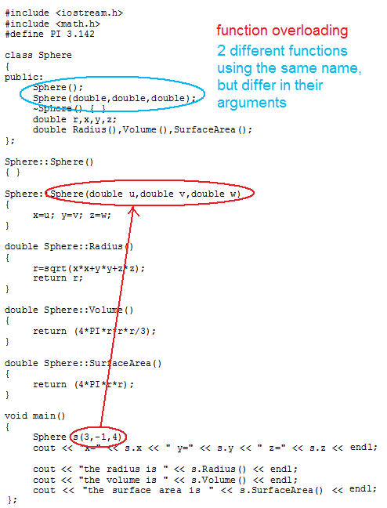

 Code6F.cpp: Overloading in functions.
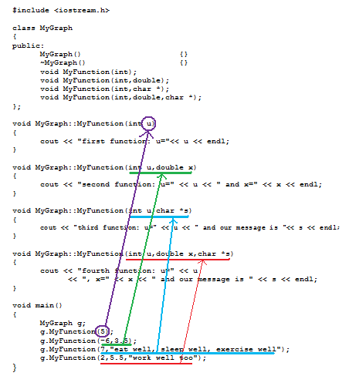
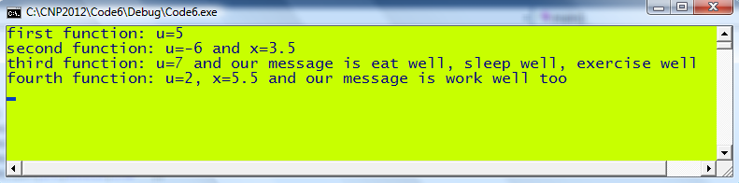
Data Passing

- The transfer of data from one function to another

 Rules for data passing between functions
- both the passing and receiving functions must be declared with the same prototypes
- both the passing and receiving functions must match in their argument types and prototypes

 Code6G.cpp: Data passing between functions.
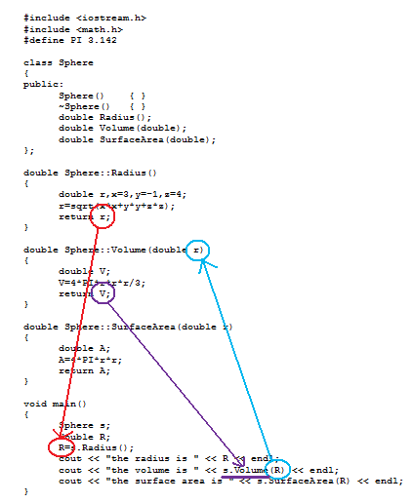

 Code6H.cpp: Array passing between functions.
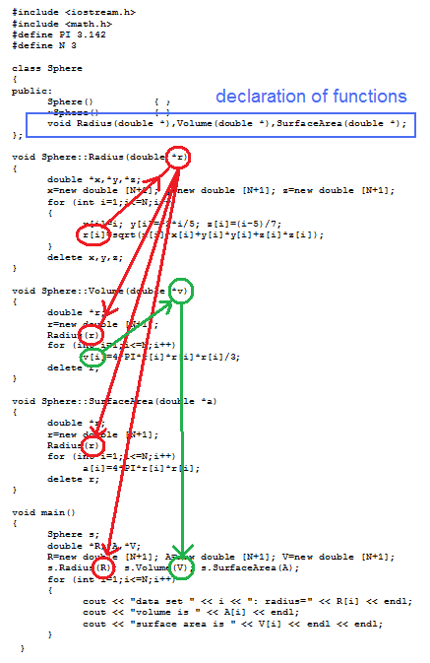
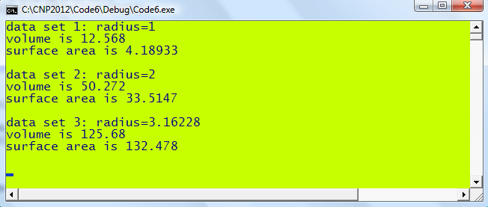

6.7 Data Passing involving Structure
 Rules for data passing
- both the passing and receiving functions must be declared with the same prototypes
- both the passing and receiving functions must match in their argument types and prototypes

POINT and LINE are structures.

Ln is a local object of LINE.

p, q, b and e are the objects of POINT.

Who are the members of POINT and LINE?

 Code6I.cpp: Class with structure.
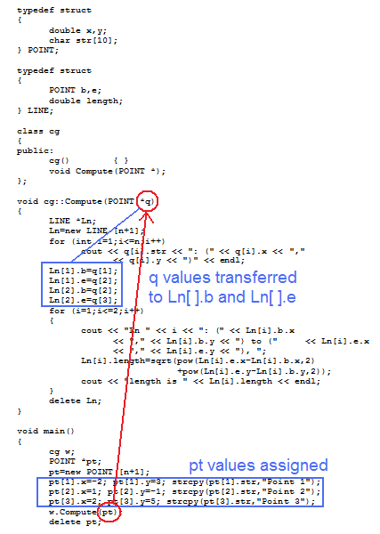
6.8 Class Inheritance
- Inheritance refers to resources such as variables belonging to an earlier class which can be shared by newer classes.
- The earlier class is called the base class
- The newer classes are called inherited classes

 Inheritance rules
- the inherited class can access any member of the base class, but not the other way around
- several levels of inheritance are supported in C++
 Code6J.cpp: Two classes collaborating.
#include <fstream>
#include <iostream>
#define N 6
using namespace std;

class A
{
public:
A() {}
~A() {}
void DataInput(int **);
};

void A::DataInput(int **p)
{
ifstream InFile("Code6J.in");
for (int i=1;i<=N;i++)
for (int j=1;j<=i;j++)
{
InFile >> p[i][j];
p[j][i]=p[i][j];
}
}

class B
{
public:
B() {}
~B() {}
void Adjacency();
};

void B::Adjacency()
{
A g;
int **q,i,j;
q=new int *[N+1];
for (i=1;i<=N;i++)
q[i]=new int [N+1];
g.DataInput(q);
cout << "Weights of adjacent edges" << endl;
for (i=1;i<=N;i++)
{
for (j=1;j<=N;j++)
if (q[i][j]!=99)
cout << "w(" << i << "," << j << ")="
<< q[i][j] << endl;
cout << endl;
}
delete q;
}

void main()
{
B m;
m.Adjacency();
cin.get();
}

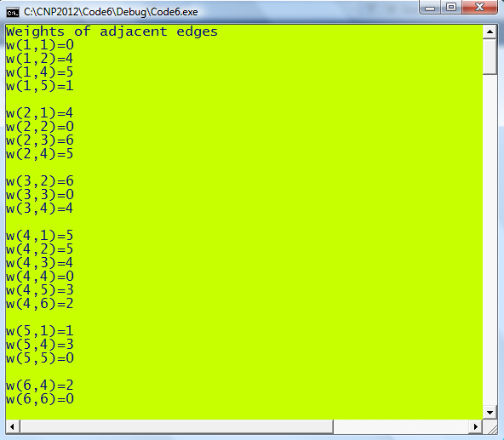

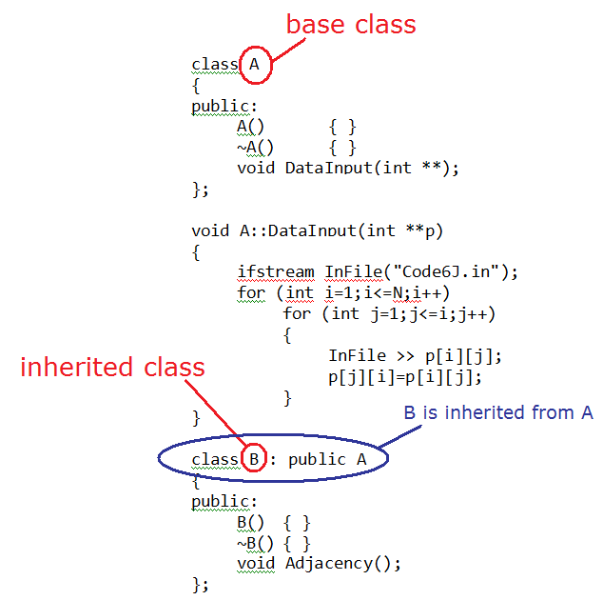
 Code6K.cpp: Illustrating inheritance.
#include <fstream>
#include <iostream>
#define N 6
using namespace std;

class A
{
public:
A() { }
~A() { }
void DataInput(int **);
};

void A::DataInput(int **p)
{
ifstream InFile("Code6J.in");
for (int i=1;i<=N;i++)
for (int j=1;j<=i;j++)
{
InFile >> p[i][j];
p[j][i]=p[i][j];
}
}

class B : public A
{
public:
B() { }
~B() { }
void Adjacency();
};

void B::Adjacency()
{
int **q,i,j;
q=new int *[N+1];
for (i=1;i<=N;i++)
q[i]=new int [N+1];
DataInput(q);
cout << "The adjacency matrix of G is given by: " <<endl;
for (i=1;i<=N;i++)
{
for (j=1;j<=N;j++)
cout << ((q[i][j]==99)?0:1) << " ";
cout << endl;
}
cout <<endl;
delete q;
}

void main()
{
B m;
m.Adjacency();
cin.get();
}

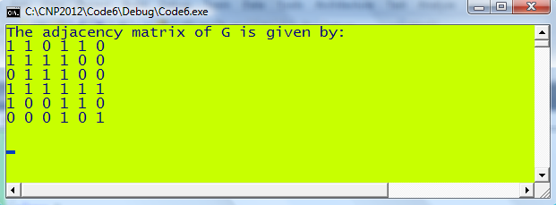

Polymorphism

- 2 or more functions using the same name which exist in two or more classes, including the base and derived classes
- For these 2 functions, a function from the base class is called by default whenever it is called (refer to Code6L.cpp)
- To override the function from the base class, always declare the function in the base class as virtual (refer to Code6M.cpp)

